Experiment - 1
To implement and demonstrate the FIND-S algorithm for finding the most specific hypothesis based on a given set of training data samples.
Procedure
- Define the training dataset.
- Initialize the hypothesis with the most specific values.
- Consider only positive training examples.
- Compare positive examples with the hypothesis.
- Replace differing attributes with '?'.
- Ignore negative examples.
- Display the final hypothesis.

Dataset 1: Play Tennis
Sky | AirTemp | Humidity | Wind | Water | Forecast | PlayTennis
Sunny | Warm | Normal | Strong | Warm | Same | Yes
Sunny | Warm | High | Strong | Warm | Same | Yes
Rainy | Cold | High | Strong | Warm | Change | No
Sunny | Warm | High | Strong | Cool | Same | Yes
Rainy | Warm | Normal | Weak | Warm | Same | No
Sunny | Warm | Normal | Weak | Warm | Same | Yes
Target Attribute: PlayTennis

Dataset 2: Loan Approval
Income | CreditScore | Employment | Property | Age | LoanApproved
High | Good | Permanent | Yes | Young | Yes
High | Good | Permanent | No | Middle | Yes
Low | Poor | Temporary | No | Young | No
Medium | Good | Permanent | Yes | Middle | Yes
High | Average | Temporary | Yes | Old | No
High | Good | Permanent | Yes | Middle | Yes
Target Attribute: LoanApproved

Dataset 3: Student Placement
CGPA | Communication | Internship | Programming | Aptitude | Placed
High | Good | Yes | Good | High | Yes
High | Excellent | Yes | Good | High | Yes
Medium | Average | No | Average | Medium | No
High | Good | Yes | Excellent | High | Yes
Low | Poor | No | Average | Low | No
High | Good | Yes | Good | Medium | Yes
Target Attribute: Placed

Dataset 4: Disease Diagnosis
Fever | Cough | Headache | BodyPain | Fatigue | Disease
Yes | Yes | Yes | Yes | Yes | Positive
Yes | Yes | No | Yes | Yes | Positive
No | Yes | Yes | No | No | Negative
Yes | Yes | Yes | No | Yes | Positive
No | No | Yes | Yes | No | Negative
Yes | Yes | No | No | Yes | Positive
Target Attribute: Disease

Dataset 5: Email Spam Detection
ContainsLink | ContainsOffer | UnknownSender | Attachment | ManyRecipients | Spam
Yes | Yes | Yes | No | Yes | Yes
Yes | Yes | Yes | Yes | Yes | Yes
No | No | No | No | No | No
Yes | No | Yes | No | Yes | Yes
No | Yes | No | Yes | No | No

Aim
To implement and demonstrate the FIND-S algorithm for finding the most specific hypothesis from the given training datasets.

Procedure
- Define the training dataset.
- Initialize the hypothesis with the most specific values.
- Consider only the positive training examples.
- Compare each positive example with the current hypothesis.
- Replace differing attribute values with ?.
- Ignore negative training examples.
- Display the final most specific hypothesis.
Program:
def find_s(data, positive_value):
hypothesis = ["Ø"] * (len(data[0]) - 1)

for row in data:
attributes = row[:-1]
target = row[-1]

if target == positive_value:
for i in range(len(hypothesis)):
if hypothesis[i] == "Ø":
hypothesis[i] = attributes[i]
elif hypothesis[i] != attributes[i]:
hypothesis[i] = "?"

return hypothesis

play_tennis = [
["Sunny", "Warm", "Normal", "Strong", "Warm", "Same", "Yes"],
["Sunny", "Warm", "High", "Strong", "Warm", "Same", "Yes"],
["Rainy", "Cold", "High", "Strong", "Warm", "Change", "No"],
["Sunny", "Warm", "High", "Strong", "Cool", "Same", "Yes"],
["Rainy", "Warm", "Normal", "Weak", "Warm", "Same", "No"],
["Sunny", "Warm", "Normal", "Weak", "Warm", "Same", "Yes"]
]

loan_approval = [
["High", "Good", "Permanent", "Yes", "Young", "Yes"],
["High", "Good", "Permanent", "No", "Middle", "Yes"],
["Low", "Poor", "Temporary", "No", "Young", "No"],
["Medium", "Good", "Permanent", "Yes", "Middle", "Yes"],
["High", "Average", "Temporary", "Yes", "Old", "No"],
["High", "Good", "Permanent", "Yes", "Middle", "Yes"]
]

student_placement = [
["High", "Good", "Yes", "Good", "High", "Yes"],
["High", "Excellent", "Yes", "Good", "High", "Yes"],
["Medium", "Average", "No", "Average", "Medium", "No"],
["High", "Good", "Yes", "Excellent", "High", "Yes"],
["Low", "Poor", "No", "Average", "Low", "No"],
["High", "Good", "Yes", "Good", "Medium", "Yes"]
]

disease_diagnosis = [
["Yes", "Yes", "Yes", "Yes", "Yes", "Positive"],
["Yes", "Yes", "No", "Yes", "Yes", "Positive"],
["No", "Yes", "Yes", "No", "No", "Negative"],
["Yes", "Yes", "Yes", "No", "Yes", "Positive"],
["No", "No", "Yes", "Yes", "No", "Negative"],
["Yes", "Yes", "No", "No", "Yes", "Positive"]
]

email_spam = [
["Yes", "Yes", "Yes", "No", "Yes", "Yes"],
["Yes", "Yes", "Yes", "Yes", "Yes", "Yes"],
["No", "No", "No", "No", "No", "No"],
["Yes", "No", "Yes", "No", "Yes", "Yes"],
["No", "Yes", "No", "Yes", "No", "No"],
["Yes", "Yes", "Yes", "No", "No", "Yes"]
]
print("DATASET 1: PLAY TENNIS")
print("Final Hypothesis:", find_s(play_tennis, "Yes"))
print("\nDATASET 2: LOAN APPROVAL")
print("Final Hypothesis:", find_s(loan_approval, "Yes"))
print("\nDATASET 3: STUDENT PLACEMENT")
print("Final Hypothesis:", find_s(student_placement, "Yes"))
print("\nDATASET 4: DISEASE DIAGNOSIS")
print("Final Hypothesis:", find_s(disease_diagnosis, "Positive"))
print("\nDATASET 5: EMAIL SPAM DETECTION")
print("Final Hypothesis:", find_s(email_spam, "Yes"))

Output:
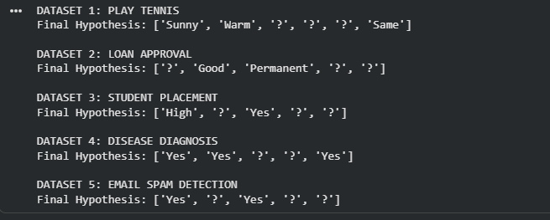

Result
The FIND-S algorithm was successfully implemented using five different datasets. The algorithm considered only the positive training examples, ignored negative examples, and generated the most specific hypothesis that is consistent with all positive examples.

Experiment – 2
2.To implement and demonstrate the Candidate Elimination algorithm and obtain all hypotheses consistent with the training examples.
Procedure
- Define the training dataset.
- Initialize the Specific hypothesis (S).
- Initialize the General hypothesis (G).
- For positive examples, generalize S.
- For negative examples, specialize G.
- Update S and G after each iteration.
- Display the final hypotheses.

Dataset 1: Play Tennis
Sky | Temperature | Humidity | Wind | Water | Forecast | PlayTennis
Sunny | Warm | Normal | Strong | Warm | Same | Yes
Sunny | Warm | High | Strong | Warm | Same | Yes
Rainy | Cold | High | Strong | Warm | Change | No
Sunny | Warm | High | Strong | Cool | Same | Yes
Rainy | Warm | Normal | Weak | Warm | Same | No
Sunny | Warm | Normal | Weak | Warm | Same | Yes
Cloudy | Warm | Normal | Strong | Warm | Same | Yes
Sunny | Cold | High | Weak | Cool | Change | No
Target Attribute: PlayTennis

Dataset 2: Loan Approval
Income | Credit Score | Employment | Property | Age | Loan Approved
High | Good | Permanent | Yes | Young | Yes
High | Good | Permanent | No | Middle | Yes
Low | Poor | Temporary | No | Young | No
Medium | Good | Permanent | Yes | Middle | Yes
High | Average | Temporary | Yes | Old | No
Medium | Good | Permanent | No | Young | Yes
Low | Good | Permanent | Yes | Middle | Yes
Low | Poor | Temporary | Yes | Old | No
Target Attribute: Loan Approved

Dataset 3: Student Placement
CGPA | Communication | Internship | Programming | Aptitude | Placed
High | Good | Yes | Good | High | Yes
High | Excellent | Yes | Good | High | Yes
Medium | Average | No | Average | Medium | No
High | Good | Yes | Excellent | High | Yes
Low | Poor | No | Average | Low | No
High | Good | Yes | Good | Medium | Yes
Medium | Good | Yes | Good | High | Yes
Low | Average | No | Poor | Medium | No
Target Attribute: Placed

Dataset 4: Disease Diagnosis
Fever | Cough | Headache | Body Pain | Fatigue | Disease
Yes | Yes | Yes | Yes | Yes | Positive
Yes | Yes | No | Yes | Yes | Positive
No | Yes | Yes | No | No | Negative
Yes | Yes | Yes | No | Yes | Positive
No | No | Yes | Yes | No | Negative
Yes | Yes | No | No | Yes | Positive
Yes | No | Yes | Yes | Yes | Positive
No | No | No | No | No | Negative
Target Attribute: Disease

Dataset 5: Email Spam Detection
Contains Link | Contains Offer | Unknown Sender | Attachment | Many Recipients | Spam
Yes | Yes | Yes | No | Yes | Yes
Yes | Yes | Yes | Yes | Yes | Yes
No | No | No | No | No | No
Yes | No | Yes | No | Yes | Yes
No | Yes | No | Yes | No | No
Yes | Yes | Yes | No | No | Yes
Yes | No | Yes | Yes | Yes | Yes
No | No | Yes | No | No | No

Aim
To implement and demonstrate the Candidate Elimination Algorithm and obtain all hypotheses consistent with the given training examples.

Procedure
- Define the training dataset.
- Initialize the Specific hypothesis S.
- Initialize the General hypothesis G.
- For positive examples, generalize S.
- For negative examples, specialize G.
- Update S and G after every iteration.
- Display the final Specific and General hypotheses.
Program:
def candidate_elimination(data, positive_value):

attributes = [row[:-1] for row in data]
targets = [row[-1] for row in data]

domains = []

for i in range(len(attributes[0])):
values = set()

for row in attributes:
values.add(row[i])

domains.append(values)

S = [["Ø"] * len(attributes[0])]
G = [["?"] * len(attributes[0])]

def covers(hypothesis, example):

for h, value in zip(hypothesis, example):

if h == "?":
continue

if h == "Ø":
return False

if h != value:
return False

return True

def more_general(h1, h2):

more_general_or_equal = True
strictly_more_general = False

for value1, value2 in zip(h1, h2):

if value1 == "?":
if value2 != "?":
strictly_more_general = True

elif value1 == "Ø":
if value2 != "Ø":
more_general_or_equal = False

elif value1 != value2:
more_general_or_equal = False

return more_general_or_equal and strictly_more_general

for example, target in zip(attributes, targets):

if target == positive_value:

G = [g for g in G if covers(g, example)]

new_S = []

for s in S:

if covers(s, example):
new_S.append(s)

else:

generalized = s.copy()

for i in range(len(generalized)):

if generalized[i] == "Ø":
generalized[i] = example[i]

elif generalized[i] != example[i]:
generalized[i] = "?"

if any(
covers(g, generalized)
for g in G
):
new_S.append(generalized)

S = new_S

S = [
s for s in S
if not any(
more_general(s, other)
for other in S
if other != s
)
]

else:

S = [s for s in S if not covers(s, example)]

new_G = []

for g in G:

if not covers(g, example):
new_G.append(g)

else:

for i in range(len(g)):

if g[i] == "?":

for value in domains[i]:

if value != example[i]:

specialized = g.copy()

specialized[i] = value

if any(
covers(s, specialized)
for s in S
):
new_G.append(specialized)

G = new_G

G = [
g for g in G
if not any(
more_general(other, g)
for other in G
if other != g
)
]

S = list(
set(tuple(h) for h in S)
)

S = [list(h) for h in S]

G = list(
set(tuple(h) for h in G)
)

G = [list(h) for h in G]

return S, G

play_tennis = [
["Sunny", "Warm", "Normal", "Strong", "Warm", "Same", "Yes"],
["Sunny", "Warm", "High", "Strong", "Warm", "Same", "Yes"],
["Rainy", "Cold", "High", "Strong", "Warm", "Change", "No"],
["Sunny", "Warm", "High", "Strong", "Cool", "Same", "Yes"],
["Rainy", "Warm", "Normal", "Weak", "Warm", "Same", "No"],
["Sunny", "Warm", "Normal", "Weak", "Warm", "Same", "Yes"],
["Cloudy", "Warm", "Normal", "Strong", "Warm", "Same", "Yes"],
["Sunny", "Cold", "High", "Weak", "Cool", "Change", "No"]
]

loan_approval = [
["High", "Good", "Permanent", "Yes", "Young", "Yes"],
["High", "Good", "Permanent", "No", "Middle", "Yes"],
["Low", "Poor", "Temporary", "No", "Young", "No"],
["Medium", "Good", "Permanent", "Yes", "Middle", "Yes"],
["High", "Average", "Temporary", "Yes", "Old", "No"],
["Medium", "Good", "Permanent", "No", "Young", "Yes"],
["Low", "Good", "Permanent", "Yes", "Middle", "Yes"],
["Low", "Poor", "Temporary", "Yes", "Old", "No"]
]

student_placement = [
["High", "Good", "Yes", "Good", "High", "Yes"],
["High", "Excellent", "Yes", "Good", "High", "Yes"],
["Medium", "Average", "No", "Average", "Medium", "No"],
["High", "Good", "Yes", "Excellent", "High", "Yes"],
["Low", "Poor", "No", "Average", "Low", "No"],
["High", "Good", "Yes", "Good", "Medium", "Yes"],
["Medium", "Good", "Yes", "Good", "High", "Yes"],
["Low", "Average", "No", "Poor", "Medium", "No"]
]

disease_diagnosis = [
["Yes", "Yes", "Yes", "Yes", "Yes", "Positive"],
["Yes", "Yes", "No", "Yes", "Yes", "Positive"],
["No", "Yes", "Yes", "No", "No", "Negative"],
["Yes", "Yes", "Yes", "No", "Yes", "Positive"],
["No", "No", "Yes", "Yes", "No", "Negative"],
["Yes", "Yes", "No", "No", "Yes", "Positive"],
["Yes", "No", "Yes", "Yes", "Yes", "Positive"],
["No", "No", "No", "No", "No", "Negative"]
]

email_spam = [
["Yes", "Yes", "Yes", "No", "Yes", "Yes"],
["Yes", "Yes", "Yes", "Yes", "Yes", "Yes"],
["No", "No", "No", "No", "No", "No"],
["Yes", "No", "Yes", "No", "Yes", "Yes"],
["No", "Yes", "No", "Yes", "No", "No"],
["Yes", "Yes", "Yes", "No", "No", "Yes"],
["Yes", "No", "Yes", "Yes", "Yes", "Yes"],
["No", "No", "Yes", "No", "No", "No"]
]

datasets = [
("DATASET 1: PLAY TENNIS", play_tennis, "Yes"),
("DATASET 2: LOAN APPROVAL", loan_approval, "Yes"),
("DATASET 3: STUDENT PLACEMENT", student_placement, "Yes"),
("DATASET 4: DISEASE DIAGNOSIS", disease_diagnosis, "Positive"),
("DATASET 5: EMAIL SPAM DETECTION", email_spam, "Yes")
]

for name, data, positive_value in datasets:

S, G = candidate_elimination(
data,
positive_value
)

print("\n" + "=" * 60)

print(name)

print("=" * 60)

print("\nFinal Specific Hypothesis (S):")

for hypothesis in S:
print(hypothesis)

print("\nFinal General Hypotheses (G):")

for hypothesis in G:
print(hypothesis)

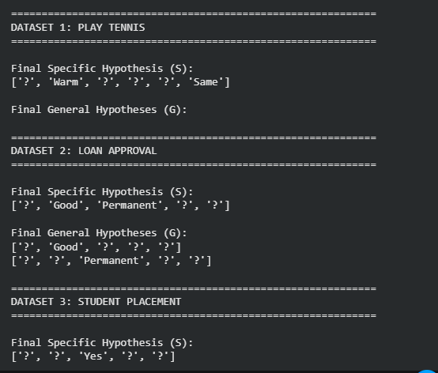
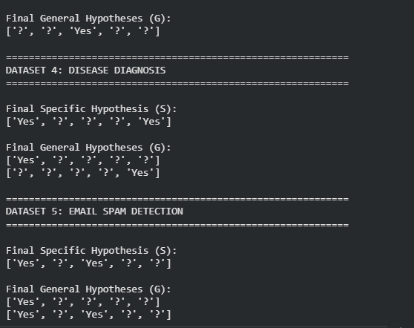
Result;
The Candidate Elimination Algorithm was successfully implemented using the five given datasets. The algorithm processed both positive and negative training examples and generated the final Specific hypothesis (S) and General hypotheses (G), representing the boundaries of the Version Space.

Experiment – 3
3. To implement and demonstrate the working of the Decision Tree based ID3 algorithm and classify a new sample.
Procedure
- Import the Decision Tree Classifier.
- Create the training dataset and target values.
- Create the Decision Tree model using entropy.
- Train the model using the training data.
- Classify a new sample using the trained model.
- Display the predicted result.

Dataset 1: Play Tennis
Outlook | Temperature | Humidity | Wind | Play Tennis
Sunny | Hot | High | Weak | No
Sunny | Hot | High | Strong | No
Overcast | Hot | High | Weak | Yes
Rain | Mild | High | Weak | Yes
Rain | Cool | Normal | Weak | Yes
Rain | Cool | Normal | Strong | No
Overcast | Cool | Normal | Strong | Yes
Sunny | Mild | High | Weak | No
Sunny | Cool | Normal | Weak | Yes
Rain | Mild | Normal | Weak | Yes
Sunny | Mild | Normal | Strong | Yes
Overcast | Mild | High | Strong | Yes
Overcast | Hot | Normal | Weak | Yes
Rain | Mild | High | Strong | No
Target Variable: Play Tennis (Yes/No)
New Sample for Prediction
Outlook | Temperature | Humidity | Wind
Sunny | Cool | High | Weak

Dataset 2: Student Placement
CGPA | Communication | Internship | Programming | Placement
High | Good | Yes | Good | Yes
High | Excellent | Yes | Excellent | Yes
Medium | Good | Yes | Good | Yes
Medium | Average | No | Average | No
Low | Poor | No | Poor | No
High | Good | No | Good | Yes
Low | Average | No | Average | No
Medium | Good | Yes | Excellent | Yes
High | Excellent | Yes | Good | Yes
Low | Poor | Yes | Average | No
Target Variable: Placement
New Sample for Prediction
CGPA | Communication | Internship | Programming
High | Good | Yes | Excellent

Dataset 3: Loan Approval
Income | Credit Score | Employment | Property | Loan Approved
High | Good | Permanent | Yes | Yes
High | Good | Permanent | No | Yes
Medium | Good | Permanent | Yes | Yes
Low | Poor | Temporary | No | No
Medium | Average | Permanent | No | Yes
High | Average | Temporary | Yes | No
Low | Poor | Temporary | Yes | No
Medium | Good | Permanent | Yes | Yes
High | Good | Permanent | Yes | Yes
Low | Average | Temporary | No | No
Target Variable: Loan Approved
New Sample for Prediction
Income | Credit Score | Employment | Property
Medium | Good | Permanent | Yes

Dataset 4: Disease Diagnosis
Fever | Cough | Headache | Body Pain | Disease
Yes | Yes | Yes | Yes | Positive
Yes | Yes | No | Yes | Positive
No | Yes | Yes | No | Negative
Yes | No | Yes | Yes | Positive
No | No | No | No | Negative
Yes | Yes | Yes | No | Positive
No | Yes | No | Yes | Negative
Yes | No | No | Yes | Positive
Yes | Yes | Yes | Yes | Positive
No | No | Yes | No | Negative
Target Variable: Disease
New Sample for Prediction
Fever | Cough | Headache | Body Pain
Yes | Yes | No | Yes

Dataset 5: Employee Promotion
Experience | Performance | Leadership | Training | Promotion
High | Excellent | Yes | Yes | Yes
High | Good | Yes | Yes | Yes
Medium | Good | No | Yes | Yes
Low | Average | No | No | No
Medium | Excellent | Yes | Yes | Yes
Low | Poor | No | No | No
High | Good | Yes | No | Yes
Medium | Average | No | Yes | No
High | Excellent | Yes | Yes | Yes
Low | Poor | No | Yes | No
Target Variable: Promotion
New Sample for Prediction
Experience | Performance | Leadership | Training
Medium | Good | Yes | Yes

Procedure for ID3 Algorithm
Use the following procedure for each dataset:
- Import the DecisionTreeClassifier from sklearn.tree.
- Create the training dataset and target values.
- Convert categorical values into numerical values (using LabelEncoder or manual encoding).
- Create the Decision Tree model using the entropy criterion:
clf = DecisionTreeClassifier(criterion="entropy")
- Train the model using:
clf.fit(X_train, y_train)
- Classify the given new sample using:
prediction = clf.predict(new_sample)
- Display the predicted result.
These datasets can be saved as CSV files for laboratory experiments:
- play_tennis.csv
- student_placement.csv
- loan_approval.csv
- disease_diagnosis.csv
- employee_promotion.csv
They are well-suited for implementing the ID3 Decision Tree Algorithm in Python using Scikit-learn with the criterion="entropy" parameter.

Aim
To implement and demonstrate the working of the Decision Tree based ID3 algorithm and classify a new sample using the trained model.

Procedure
- Import DecisionTreeClassifier from sklearn.tree.
- Create the training dataset and target values.
- Convert categorical values into numerical values using LabelEncoder.
- Create the Decision Tree model using the entropy criterion.
- Train the model using the training data.
- Classify the given new sample.
- Display the predicted result.
Program:
from sklearn.tree import DecisionTreeClassifier
from sklearn.preprocessing import LabelEncoder

def id3_prediction(dataset, new_sample, dataset_name):

X = [row[:-1] for row in dataset]
y = [row[-1] for row in dataset]

encoded_X = []

encoders = []

for column in range(len(X[0])):

encoder = LabelEncoder()

column_values = [
row[column] for row in X
]

encoder.fit(column_values)

encoded_column = encoder.transform(
column_values
)

encoders.append(encoder)

if column == 0:

encoded_X = [
[value]
for value in encoded_column
]

else:

for row in range(len(X)):

encoded_X[row].append(
encoded_column[row]
)

target_encoder = LabelEncoder()

encoded_y = target_encoder.fit_transform(y)

encoded_new_sample = []

for i in range(len(new_sample)):

value = encoders[i].transform(
[new_sample[i]]
)[0]

encoded_new_sample.append(value)

model = DecisionTreeClassifier(
criterion="entropy",
random_state=42
)

model.fit(
encoded_X,
encoded_y
)

prediction = model.predict(
[encoded_new_sample]
)

result = target_encoder.inverse_transform(
prediction
)[0]

print("\n" + "=" * 60)

print(dataset_name)

print("=" * 60)

print("New Sample:")

print(new_sample)

print("\nPredicted Result:")

print(result)

play_tennis = [
["Sunny", "Hot", "High", "Weak", "No"],
["Sunny", "Hot", "High", "Strong", "No"],
["Overcast", "Hot", "High", "Weak", "Yes"],
["Rain", "Mild", "High", "Weak", "Yes"],
["Rain", "Cool", "Normal", "Weak", "Yes"],
["Rain", "Cool", "Normal", "Strong", "No"],
["Overcast", "Cool", "Normal", "Strong", "Yes"],
["Sunny", "Mild", "High", "Weak", "No"],
["Sunny", "Cool", "Normal", "Weak", "Yes"],
["Rain", "Mild", "Normal", "Weak", "Yes"],
["Sunny", "Mild", "Normal", "Strong", "Yes"],
["Overcast", "Mild", "High", "Strong", "Yes"],
["Overcast", "Hot", "Normal", "Weak", "Yes"],
["Rain", "Mild", "High", "Strong", "No"]
]

new_play_tennis = [
"Sunny",
"Cool",
"High",
"Weak"
]

student_placement = [
["High", "Good", "Yes", "Good", "Yes"],
["High", "Excellent", "Yes", "Excellent", "Yes"],
["Medium", "Good", "Yes", "Good", "Yes"],
["Medium", "Average", "No", "Average", "No"],
["Low", "Poor", "No", "Poor", "No"],
["High", "Good", "No", "Good", "Yes"],
["Low", "Average", "No", "Average", "No"],
["Medium", "Good", "Yes", "Excellent", "Yes"],
["High", "Excellent", "Yes", "Good", "Yes"],
["Low", "Poor", "Yes", "Average", "No"]
]

new_student = [
"High",
"Good",
"Yes",
"Excellent"
]

loan_approval = [
["High", "Good", "Permanent", "Yes", "Yes"],
["High", "Good", "Permanent", "No", "Yes"],
["Medium", "Good", "Permanent", "Yes", "Yes"],
["Low", "Poor", "Temporary", "No", "No"],
["Medium", "Average", "Permanent", "No", "Yes"],
["High", "Average", "Temporary", "Yes", "No"],
["Low", "Poor", "Temporary", "Yes", "No"],
["Medium", "Good", "Permanent", "Yes", "Yes"],
["High", "Good", "Permanent", "Yes", "Yes"],
["Low", "Average", "Temporary", "No", "No"]
]

new_loan = [
"Medium",
"Good",
"Permanent",
"Yes"
]

disease_diagnosis = [
["Yes", "Yes", "Yes", "Yes", "Positive"],
["Yes", "Yes", "No", "Yes", "Positive"],
["No", "Yes", "Yes", "No", "Negative"],
["Yes", "No", "Yes", "Yes", "Positive"],
["No", "No", "No", "No", "Negative"],
["Yes", "Yes", "Yes", "No", "Positive"],
["No", "Yes", "No", "Yes", "Negative"],
["Yes", "No", "No", "Yes", "Positive"],
["Yes", "Yes", "Yes", "Yes", "Positive"],
["No", "No", "Yes", "No", "Negative"]
]

new_disease = [
"Yes",
"Yes",
"No",
"Yes"
]

employee_promotion = [
["High", "Excellent", "Yes", "Yes", "Yes"],
["High", "Good", "Yes", "Yes", "Yes"],
["Medium", "Good", "No", "Yes", "Yes"],
["Low", "Average", "No", "No", "No"],
["Medium", "Excellent", "Yes", "Yes", "Yes"],
["Low", "Poor", "No", "No", "No"],
["High", "Good", "Yes", "No", "Yes"],
["Medium", "Average", "No", "Yes", "No"],
["High", "Excellent", "Yes", "Yes", "Yes"],
["Low", "Poor", "No", "Yes", "No"]
]

new_employee = [
"Medium",
"Good",
"Yes",
"Yes"
]

id3_prediction(
play_tennis,
new_play_tennis,
"DATASET 1: PLAY TENNIS"
)

id3_prediction(
student_placement,
new_student,
"DATASET 2: STUDENT PLACEMENT"
)

id3_prediction(
loan_approval,
new_loan,
"DATASET 3: LOAN APPROVAL"
)

id3_prediction(
disease_diagnosis,
new_disease,
"DATASET 4: DISEASE DIAGNOSIS"
)

id3_prediction(
employee_promotion,
new_employee,
"DATASET 5: EMPLOYEE PROMOTION"
)
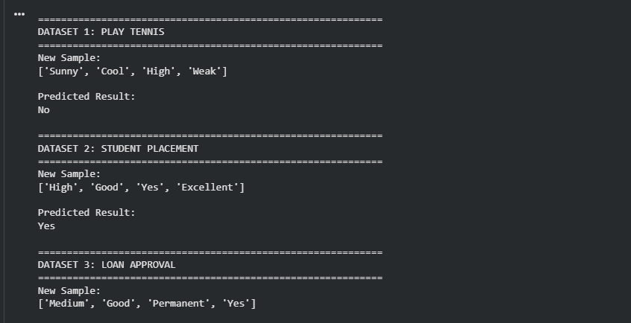
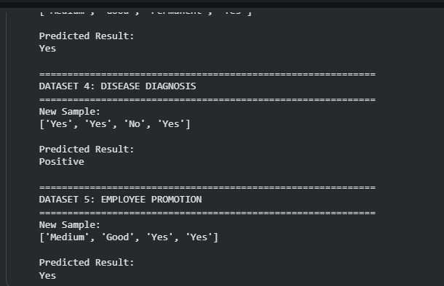

Result
The Decision Tree based ID3 algorithm was successfully implemented using DecisionTreeClassifier with criterion="entropy". The model was trained using the given categorical datasets and successfully classified the new samples.
Experiment - 4
4. To build an Artificial Neural Network using the Backpropagation algorithm and classify a new sample.
Procedure
- Import the MLPClassifier.
- Create the training dataset and target values.
- Create the ANN model.
- Train the model using Backpropagation.
- Test the model using a new sample.
- Display the predicted result.

Dataset 1: Student Placement Prediction
CGPA | Communication | Internship | Programming | Placement
9 | Excellent | Yes | Excellent | Placed
8 | Good | Yes | Good | Placed
7 | Good | Yes | Average | Placed
6 | Average | No | Average | Not Placed
5 | Poor | No | Poor | Not Placed
9 | Excellent | Yes | Good | Placed
8 | Good | No | Good | Placed
6 | Average | Yes | Average | Not Placed
7 | Excellent | Yes | Good | Placed
5 | Poor | No | Average | Not Placed

Target Variable
Placement (Placed / Not Placed)

New Sample
CGPA | Communication | Internship | Programming
8 | Excellent | Yes | Good

Dataset 2: Loan Approval Prediction
Income | Credit Score | Employment | Property | Loan Approved
High | Good | Permanent | Yes | Yes
High | Good | Permanent | No | Yes
Medium | Good | Permanent | Yes | Yes
Medium | Average | Permanent | No | Yes
Low | Poor | Temporary | No | No
Low | Average | Temporary | Yes | No
High | Average | Permanent | Yes | Yes
Medium | Good | Temporary | No | No
High | Good | Permanent | Yes | Yes
Low | Poor | Temporary | Yes | No

Target Variable
Loan Approved (Yes / No)

New Sample
Income | Credit Score | Employment | Property
Medium | Good | Permanent | Yes

Dataset 3: Disease Diagnosis
Fever | Cough | Headache | Body Pain | Fatigue | Disease
Yes | Yes | Yes | Yes | Yes | Positive
Yes | Yes | No | Yes | Yes | Positive
No | Yes | Yes | No | No | Negative
Yes | No | Yes | Yes | Yes | Positive
No | No | No | No | No | Negative
Yes | Yes | Yes | No | Yes | Positive
No | Yes | No | Yes | No | Negative
Yes | No | No | Yes | Yes | Positive
Yes | Yes | Yes | Yes | Yes | Positive
No | No | Yes | No | No | Negative

Target Variable
Disease (Positive / Negative)

New Sample
Fever | Cough | Headache | Body Pain | Fatigue
Yes | Yes | No | Yes | Yes

Dataset 4: Employee Promotion Prediction
Experience | Performance | Leadership | Training | Promotion
High | Excellent | Yes | Yes | Promoted
High | Good | Yes | Yes | Promoted
Medium | Good | Yes | Yes | Promoted
Medium | Average | No | Yes | Not Promoted
Low | Poor | No | No | Not Promoted
High | Excellent | Yes | No | Promoted
Medium | Good | No | Yes | Promoted
Low | Average | No | No | Not Promoted
High | Good | Yes | Yes | Promoted
Low | Poor | No | Yes | Not Promoted

Target Variable
Promotion (Promoted / Not Promoted)

New Sample
Experience | Performance | Leadership | Training
Medium | Good | Yes | Yes

Dataset 5: Email Spam Detection
Contains Link | Offer Words | Unknown Sender | Attachment | Many Recipients | Spam
Yes | Yes | Yes | No | Yes | Spam
Yes | Yes | Yes | Yes | Yes | Spam
No | No | No | No | No | Not Spam
Yes | No | Yes | No | Yes | Spam
No | Yes | No | Yes | No | Not Spam
Yes | Yes | Yes | No | No | Spam
Yes | No | Yes | Yes | Yes | Spam
No | No | Yes | No | No | Not Spam
Yes | Yes | No | No | Yes | Spam
No | No | No | Yes | No | Not Spam

Target Variable
Spam (Spam / Not Spam)

New Sample
Contains Link | Offer Words | Unknown Sender | Attachment | Many Recipients
Yes | Yes | Yes | No | Yes

Procedure for ANN using Backpropagation
For each dataset, follow these steps:
- Import the required libraries:
- from sklearn.neural_network import MLPClassifier
from sklearn.preprocessing import LabelEncoder
- Load or create the training dataset.
- Convert categorical values into numerical values using LabelEncoder (if applicable).
- Separate the dataset into:
  - Input features (X)
  - Target values (y)
- Create the Artificial Neural Network model:
- model = MLPClassifier(hidden_layer_sizes=(5,),
- activation='relu',
- solver='adam',
- max_iter=1000,
random_state=42)
- Train the model using:
model.fit(X, y)
- Test the model with the new sample:
prediction = model.predict(new_sample)
- Display the predicted result:
print("Predicted Class:", prediction)

Suggested CSV File Names
- student_placement_ann.csv
- loan_approval_ann.csv
- disease_diagnosis_ann.csv
- employee_promotion_ann.csv
- email_spam_ann.csv
These datasets are designed for laboratory experiments on Artificial Neural Networks (ANNs) using the Backpropagation algorithm with Scikit-learn's MLPClassifier.

Aim
To build an Artificial Neural Network (ANN) using the Backpropagation algorithm and classify a new sample.

Procedure
- Import MLPClassifier.
- Create the training dataset and target values.
- Convert categorical values into numerical values using LabelEncoder.
- Create the ANN model.
- Train the ANN using Backpropagation.
- Test the model using the given new sample.
- Display the predicted result.
Program:
from sklearn.neural_network import MLPClassifier
from sklearn.preprocessing import LabelEncoder
from sklearn.preprocessing import StandardScaler
import warnings

warnings.filterwarnings("ignore")

def ann_prediction(dataset, new_sample, dataset_name):

X = [row[:-1] for row in dataset]
y = [row[-1] for row in dataset]

feature_encoders = []

encoded_X = []

for row in X:
encoded_X.append([])

for column in range(len(X[0])):

values = [
row[column]
for row in X
]

numeric_values = True

try:

[float(value) for value in values]

except ValueError:

numeric_values = False

if numeric_values:

for row in range(len(X)):

encoded_X[row].append(
float(X[row][column])
)

feature_encoders.append(None)

else:

encoder = LabelEncoder()

encoder.fit(values)

for row in range(len(X)):

encoded_value = encoder.transform(
[X[row][column]]
)[0]

encoded_X[row].append(
encoded_value
)

feature_encoders.append(
encoder
)

encoded_new_sample = []

for column in range(
len(new_sample)
):

if feature_encoders[column] is None:

encoded_new_sample.append(
float(
new_sample[column]
)
)

else:

encoded_value = (
feature_encoders[column]
.transform(
[new_sample[column]]
)[0]
)

encoded_new_sample.append(
encoded_value
)

target_encoder = LabelEncoder()

encoded_y = target_encoder.fit_transform(
y
)

scaler = StandardScaler()

scaled_X = scaler.fit_transform(
encoded_X
)

scaled_new_sample = (
scaler.transform(
[encoded_new_sample]
)
)

model = MLPClassifier(
hidden_layer_sizes=(5,),
activation="relu",
solver="adam",
max_iter=1000,
random_state=42
)

model.fit(
scaled_X,
encoded_y
)

prediction = model.predict(
scaled_new_sample
)

predicted_result = (
target_encoder.inverse_transform(
prediction
)[0]
)

print("\n" + "=" * 60)

print(dataset_name)

print("=" * 60)

print("\nNew Sample:")

print(new_sample)

print("\nPredicted Result:")

print(predicted_result)

student_placement = [

[9, "Excellent", "Yes", "Excellent", "Placed"],

[8, "Good", "Yes", "Good", "Placed"],

[7, "Good", "Yes", "Average", "Placed"],

[6, "Average", "No", "Average", "Not Placed"],

[5, "Poor", "No", "Poor", "Not Placed"],

[9, "Excellent", "Yes", "Good", "Placed"],

[8, "Good", "No", "Good", "Placed"],

[6, "Average", "Yes", "Average", "Not Placed"],

[7, "Excellent", "Yes", "Good", "Placed"],

[5, "Poor", "No", "Average", "Not Placed"]

]

new_student = [

8,

"Excellent",

"Yes",

"Good"

]

loan_approval = [

["High", "Good", "Permanent", "Yes", "Yes"],

["High", "Good", "Permanent", "No", "Yes"],

["Medium", "Good", "Permanent", "Yes", "Yes"],

["Medium", "Average", "Permanent", "No", "Yes"],

["Low", "Poor", "Temporary", "No", "No"],

["Low", "Average", "Temporary", "Yes", "No"],

["High", "Average", "Permanent", "Yes", "Yes"],

["Medium", "Good", "Temporary", "No", "No"],

["High", "Good", "Permanent", "Yes", "Yes"],

["Low", "Poor", "Temporary", "Yes", "No"]

]

new_loan = [

"Medium",

"Good",

"Permanent",

"Yes"

]

disease_diagnosis = [

["Yes", "Yes", "Yes", "Yes", "Yes", "Positive"],

["Yes", "Yes", "No", "Yes", "Yes", "Positive"],

["No", "Yes", "Yes", "No", "No", "Negative"],

["Yes", "No", "Yes", "Yes", "Yes", "Positive"],

["No", "No", "No", "No", "No", "Negative"],

["Yes", "Yes", "Yes", "No", "Yes", "Positive"],

["No", "Yes", "No", "Yes", "No", "Negative"],

["Yes", "No", "No", "Yes", "Yes", "Positive"],

["Yes", "Yes", "Yes", "Yes", "Yes", "Positive"],

["No", "No", "Yes", "No", "No", "Negative"]

]

new_disease = [

"Yes",

"Yes",

"No",

"Yes",

"Yes"

]

employee_promotion = [

["High", "Excellent", "Yes", "Yes", "Promoted"],

["High", "Good", "Yes", "Yes", "Promoted"],

["Medium", "Good", "Yes", "Yes", "Promoted"],

["Medium", "Average", "No", "Yes", "Not Promoted"],

["Low", "Poor", "No", "No", "Not Promoted"],

["High", "Excellent", "Yes", "No", "Promoted"],

["Medium", "Good", "No", "Yes", "Promoted"],

["Low", "Average", "No", "No", "Not Promoted"],

["High", "Good", "Yes", "Yes", "Promoted"],

["Low", "Poor", "No", "Yes", "Not Promoted"]

]

new_employee = [

"Medium",

"Good",

"Yes",

"Yes"

]

email_spam = [

["Yes", "Yes", "Yes", "No", "Yes", "Spam"],

["Yes", "Yes", "Yes", "Yes", "Yes", "Spam"],

["No", "No", "No", "No", "No", "Not Spam"],

["Yes", "No", "Yes", "No", "Yes", "Spam"],

["No", "Yes", "No", "Yes", "No", "Not Spam"],

["Yes", "Yes", "Yes", "No", "No", "Spam"],

["Yes", "No", "Yes", "Yes", "Yes", "Spam"],

["No", "No", "Yes", "No", "No", "Not Spam"],

["Yes", "Yes", "No", "No", "Yes", "Spam"],

["No", "No", "No", "Yes", "No", "Not Spam"]

]

new_email = [

"Yes",

"Yes",

"Yes",

"No",

"Yes"

]

ann_prediction(

student_placement,

new_student,

"DATASET 1: STUDENT PLACEMENT"

)

ann_prediction(

loan_approval,

new_loan,

"DATASET 2: LOAN APPROVAL"

)

ann_prediction(

disease_diagnosis,

new_disease,

"DATASET 3: DISEASE DIAGNOSIS"

)

ann_prediction(

employee_promotion,

new_employee,

"DATASET 4: EMPLOYEE PROMOTION"

)

ann_prediction(

email_spam,

new_email,

"DATASET 5: EMAIL SPAM DETECTION"

)
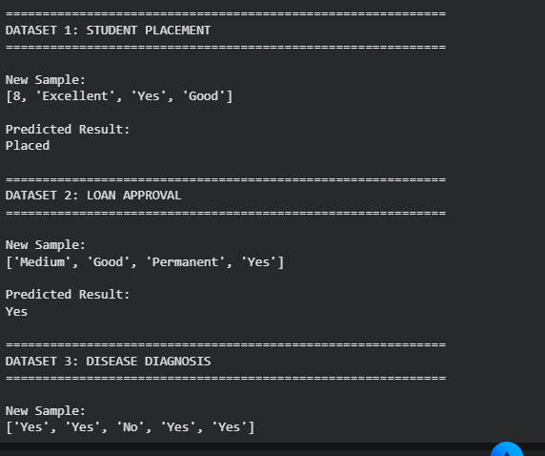
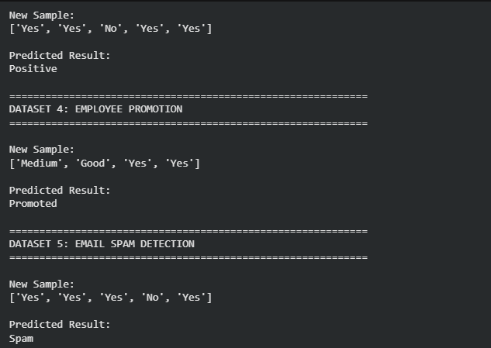

Result
The Artificial Neural Network (ANN) was successfully implemented using Scikit-learn’s MLPClassifier. The ANN was trained using the Backpropagation algorithm, and the new samples were successfully classified. The categorical attributes were converted into numerical values using LabelEncoder, while feature scaling was performed using StandardScaler.

Experiment - 5
5. To implement the K-Nearest Neighbours (K-NN) algorithm in Python and classify a new sample.
Procedure
- Import the KNeighborsClassifier.
- Create the training dataset and class labels.
- Create the K-NN model with K = 3.
- Train the model using the training data.
- Predict the class of a new sample.
- Display the predicted result.

Dataset 1: Student Placement Prediction
CGPA | Aptitude Score | Communication Score | Placement
9.2 | 90 | 88 | Placed
8.8 | 85 | 82 | Placed
8.5 | 80 | 79 | Placed
7.2 | 72 | 70 | Not Placed
6.8 | 68 | 65 | Not Placed
9.0 | 92 | 90 | Placed
7.5 | 75 | 74 | Not Placed
8.6 | 84 | 81 | Placed
6.5 | 60 | 58 | Not Placed
8.9 | 88 | 86 | Placed

Target Variable
Placement (Placed / Not Placed)

New Sample
CGPA | Aptitude Score | Communication Score
8.7 | 86 | 84

Dataset 2: Loan Approval Prediction
Income (₹ Lakhs) | Credit Score | Loan Amount (₹ Lakhs) | Loan Approved
8 | 780 | 5 | Yes
7 | 760 | 4 | Yes
6 | 720 | 6 | Yes
4 | 620 | 8 | No
3 | 580 | 10 | No
9 | 800 | 4 | Yes
5 | 650 | 7 | No
8 | 770 | 5 | Yes
4 | 600 | 9 | No
7 | 740 | 6 | Yes

Target Variable
Loan Approved (Yes / No)

New Sample
Income | Credit Score | Loan Amount
7 | 750 | 5

Dataset 3: Disease Diagnosis
Temperature (°C) | Heart Rate (bpm) | Oxygen Level (%) | Disease
39.0 | 110 | 94 | Positive
38.5 | 108 | 95 | Positive
37.0 | 78 | 99 | Negative
39.2 | 115 | 93 | Positive
36.8 | 75 | 98 | Negative
38.8 | 112 | 94 | Positive
37.2 | 80 | 98 | Negative
39.1 | 114 | 92 | Positive
36.7 | 74 | 99 | Negative
38.9 | 111 | 93 | Positive

Target Variable
Disease (Positive / Negative)

New Sample
Temperature | Heart Rate | Oxygen Level
38.7 | 109 | 94

Dataset 4: Employee Promotion Prediction
Experience (Years) | Performance Score | Training Hours | Promotion
10 | 95 | 50 | Yes
8 | 90 | 45 | Yes
7 | 88 | 40 | Yes
3 | 65 | 20 | No
2 | 60 | 18 | No
9 | 93 | 48 | Yes
4 | 70 | 25 | No
8 | 89 | 42 | Yes
2 | 58 | 15 | No
6 | 85 | 38 | Yes

Target Variable
Promotion (Yes / No)

New Sample
Experience | Performance Score | Training Hours
7 | 90 | 44

Dataset 5: Fruit Classification
Weight (g) | Diameter (cm) | Sweetness (%) | Fruit
150 | 7.5 | 90 | Apple
160 | 7.8 | 88 | Apple
140 | 7.2 | 91 | Apple
120 | 5.5 | 70 | Orange
125 | 5.8 | 72 | Orange
130 | 6.0 | 74 | Orange
155 | 7.6 | 89 | Apple
118 | 5.4 | 69 | Orange
148 | 7.4 | 92 | Apple
122 | 5.7 | 71 | Orange

Target Variable
Fruit (Apple / Orange)

New Sample
Weight | Diameter | Sweetness
152 | 7.5 | 90

Procedure for K-Nearest Neighbours (K-NN)
Use the following procedure for each dataset:
- Import the required library:
from sklearn.neighbors import KNeighborsClassifier
- Create the training dataset (X) and class labels (y).
- Create the K-NN model with K = 3:
model = KNeighborsClassifier(n_neighbors=3)
- Train the model:
model.fit(X, y)
- Predict the class of a new sample:
prediction = model.predict(new_sample)
- Display the predicted result:
print("Predicted Class:", prediction)

Suggested CSV File Names
- student_placement_knn.csv
- loan_approval_knn.csv
- disease_diagnosis_knn.csv
- employee_promotion_knn.csv
- fruit_classification_knn.csv
These datasets are suitable for undergraduate machine learning laboratory exercises using the K-Nearest Neighbours (K-NN) algorithm. They use numerical features, making them directly compatible with KNeighborsClassifier in Scikit-learn.

Aim
To implement the K-Nearest Neighbours (K-NN) algorithm in Python and classify a new sample using K = 3.

Procedure
- Import KNeighborsClassifier.
- Create the training dataset and class labels.
- Create the K-NN model with K = 3.
- Train the model using the training data.
- Predict the class of a new sample.
- Display the predicted result.
Program:
from sklearn.neighbors import KNeighborsClassifier
from sklearn.preprocessing import StandardScaler

def knn_prediction(X, y, new_sample, dataset_name):

scaler = StandardScaler()

X_scaled = scaler.fit_transform(X)

new_sample_scaled = scaler.transform(
[new_sample]
)

model = KNeighborsClassifier(
n_neighbors=3
)

model.fit(
X_scaled,
y
)

prediction = model.predict(
new_sample_scaled
)

print("\n" + "=" * 60)

print(dataset_name)

print("=" * 60)

print("\nNew Sample:")

print(new_sample)

print("\nPredicted Result:")

print(prediction[0])

student_X = [
[9.2, 90, 88],
[8.8, 85, 82],
[8.5, 80, 79],
[7.2, 72, 70],
[6.8, 68, 65],
[9.0, 92, 90],
[7.5, 75, 74],
[8.6, 84, 81],
[6.5, 60, 58],
[8.9, 88, 86]
]

student_y = [
"Placed",
"Placed",
"Placed",
"Not Placed",
"Not Placed",
"Placed",
"Not Placed",
"Placed",
"Not Placed",
"Placed"
]

new_student = [
8.7,
86,
84
]

loan_X = [
[8, 780, 5],
[7, 760, 4],
[6, 720, 6],
[4, 620, 8],
[3, 580, 10],
[9, 800, 4],
[5, 650, 7],
[8, 770, 5],
[4, 600, 9],
[7, 740, 6]
]

loan_y = [
"Yes",
"Yes",
"Yes",
"No",
"No",
"Yes",
"No",
"Yes",
"No",
"Yes"
]

new_loan = [
7,
750,
5
]

disease_X = [
[39.0, 110, 94],
[38.5, 108, 95],
[37.0, 78, 99],
[39.2, 115, 93],
[36.8, 75, 98],
[38.8, 112, 94],
[37.2, 80, 98],
[39.1, 114, 92],
[36.7, 74, 99],
[38.9, 111, 93]
]

disease_y = [
"Positive",
"Positive",
"Negative",
"Positive",
"Negative",
"Positive",
"Negative",
"Positive",
"Negative",
"Positive"
]

new_disease = [
38.7,
109,
94
]

employee_X = [
[10, 95, 50],
[8, 90, 45],
[7, 88, 40],
[3, 65, 20],
[2, 60, 18],
[9, 93, 48],
[4, 70, 25],
[8, 89, 42],
[2, 58, 15],
[6, 85, 38]
]

employee_y = [
"Yes",
"Yes",
"Yes",
"No",
"No",
"Yes",
"No",
"Yes",
"No",
"Yes"
]

new_employee = [
7,
90,
44
]

fruit_X = [
[150, 7.5, 90],
[160, 7.8, 88],
[140, 7.2, 91],
[120, 5.5, 70],
[125, 5.8, 72],
[130, 6.0, 74],
[155, 7.6, 89],
[118, 5.4, 69],
[148, 7.4, 92],
[122, 5.7, 71]
]

fruit_y = [
"Apple",
"Apple",
"Apple",
"Orange",
"Orange",
"Orange",
"Apple",
"Orange",
"Apple",
"Orange"
]

new_fruit = [
152,
7.5,
90
]

knn_prediction(
student_X,
student_y,
new_student,
"DATASET 1: STUDENT PLACEMENT"
)

knn_prediction(
loan_X,
loan_y,
new_loan,
"DATASET 2: LOAN APPROVAL"
)

knn_prediction(
disease_X,
disease_y,
new_disease,
"DATASET 3: DISEASE DIAGNOSIS"
)

knn_prediction(
employee_X,
employee_y,
new_employee,
"DATASET 4: EMPLOYEE PROMOTION"
)

knn_prediction(
fruit_X,
fruit_y,
new_fruit,
"DATASET 5: FRUIT CLASSIFICATION"
)
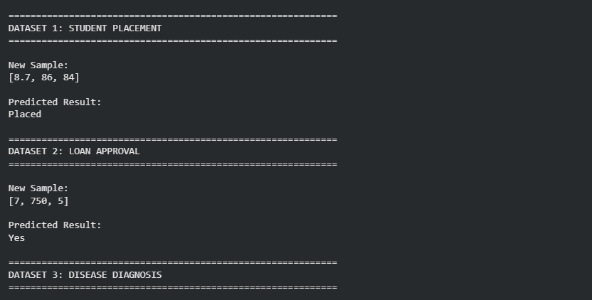
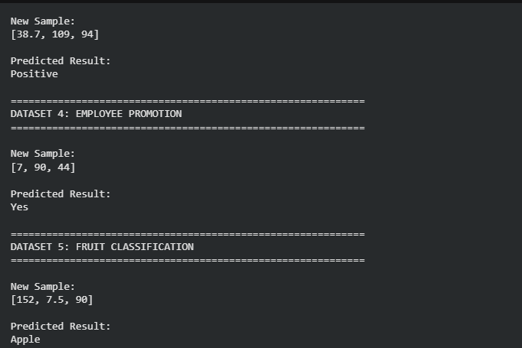

Result
The K-Nearest Neighbours (K-NN) algorithm was successfully implemented using KNeighborsClassifier with K = 3. The model was trained using the given numerical datasets and successfully classified the new samples.

Experiment - 6
6. To implement the Naïve Bayes algorithm and evaluate its performance using confusion matrix and accuracy.
Procedure
- Import GaussianNB, confusion matrix, and accuracy score.
- Create the dataset and class labels.
- Train the Naïve Bayes model.
- Predict the class labels.
- Calculate the confusion matrix and accuracy.
- Display the results.

Dataset 1: Student Placement Prediction
CGPA | Aptitude Score | Communication Score | Placement
9.1 | 90 | 88 | Placed
8.8 | 85 | 84 | Placed
8.2 | 82 | 80 | Placed
7.0 | 70 | 68 | Not Placed
6.5 | 65 | 60 | Not Placed
9.3 | 92 | 90 | Placed
7.4 | 72 | 70 | Not Placed
8.7 | 86 | 83 | Placed
6.8 | 67 | 65 | Not Placed
9.0 | 89 | 87 | Placed

Target Variable
Placement (Placed / Not Placed)

Dataset 2: Loan Approval Prediction
Income (₹ Lakhs) | Credit Score | Loan Amount (₹ Lakhs) | Loan Approved
8 | 780 | 5 | Yes
7 | 760 | 4 | Yes
6 | 730 | 5 | Yes
4 | 620 | 8 | No
3 | 590 | 9 | No
9 | 810 | 4 | Yes
5 | 650 | 7 | No
8 | 770 | 5 | Yes
4 | 610 | 8 | No
7 | 750 | 6 | Yes

Target Variable
Loan Approved (Yes / No)

Dataset 3: Disease Diagnosis
Temperature (°C) | Heart Rate (bpm) | Oxygen Level (%) | Disease
39.1 | 112 | 94 | Positive
38.8 | 109 | 95 | Positive
37.0 | 78 | 99 | Negative
39.3 | 115 | 93 | Positive
36.8 | 74 | 98 | Negative
38.7 | 110 | 94 | Positive
37.1 | 80 | 98 | Negative
39.0 | 113 | 92 | Positive
36.9 | 76 | 99 | Negative
38.9 | 111 | 93 | Positive

Target Variable
Disease (Positive / Negative)

Dataset 4: Employee Promotion Prediction
Experience (Years) | Performance Score | Training Hours | Promotion
10 | 95 | 50 | Yes
9 | 92 | 48 | Yes
8 | 90 | 45 | Yes
4 | 70 | 25 | No
3 | 65 | 20 | No
11 | 96 | 52 | Yes
5 | 75 | 30 | No
8 | 89 | 44 | Yes
2 | 60 | 18 | No
7 | 87 | 40 | Yes

Target Variable
Promotion (Yes / No)

Dataset 5: Fruit Classification
Weight (g) | Diameter (cm) | Sweetness (%) | Fruit
150 | 7.5 | 90 | Apple
160 | 7.8 | 88 | Apple
145 | 7.3 | 91 | Apple
120 | 5.5 | 70 | Orange
125 | 5.8 | 72 | Orange
130 | 6.0 | 74 | Orange
155 | 7.6 | 89 | Apple
118 | 5.4 | 69 | Orange
148 | 7.4 | 92 | Apple
122 | 5.7 | 71 | Orange

Target Variable
Fruit (Apple / Orange)

Procedure for Naïve Bayes (GaussianNB)
For each dataset, follow these steps:
- Import the required libraries:
- from sklearn.naive_bayes import GaussianNB
- from sklearn.metrics import confusion_matrix, accuracy_score
from sklearn.model_selection import train_test_split
- Create the dataset and class labels (X and y).
- Split the dataset into training and testing sets:
- X_train, X_test, y_train, y_test = train_test_split(
- X, y, test_size=0.3, random_state=42
)
- Train the Naïve Bayes model:
- model = GaussianNB()
model.fit(X_train, y_train)
- Predict the class labels:
y_pred = model.predict(X_test)
- Calculate the confusion matrix and accuracy:
- cm = confusion_matrix(y_test, y_pred)
accuracy = accuracy_score(y_test, y_pred)
- Display the results:
- print("Confusion Matrix:")
- print(cm)

print("Accuracy:", accuracy)

Suggested CSV File Names
- student_placement_nb.csv
- loan_approval_nb.csv
- disease_diagnosis_nb.csv
- employee_promotion_nb.csv
- fruit_classification_nb.csv
These datasets are appropriate for laboratory experiments using the Gaussian Naïve Bayes classifier in Scikit-learn. They are designed for binary classification tasks and allow students to evaluate model performance using a confusion matrix and accuracy score.

Aim
To implement the Gaussian Naïve Bayes algorithm and evaluate its performance using a Confusion Matrix and Accuracy Score.

Procedure
- Import GaussianNB, confusion_matrix, accuracy_score, and train_test_split.
- Create the input dataset X and target labels y.
- Split the dataset into training and testing sets.
- Create and train the Gaussian Naïve Bayes model.
- Predict the class labels for the test data.
- Calculate the confusion matrix.
- Calculate the accuracy score.
- Display the actual values, predicted values, confusion matrix, and accuracy.
Program:
from sklearn.naive_bayes import GaussianNB
from sklearn.metrics import confusion_matrix
from sklearn.metrics import accuracy_score
from sklearn.model_selection import train_test_split

def naive_bayes_evaluation(
X,
y,
dataset_name
):

X_train, X_test, y_train, y_test = (
train_test_split(
X,
y,
test_size=0.3,
random_state=42,
stratify=y
)
)

model = GaussianNB()

model.fit(
X_train,
y_train
)

y_pred = model.predict(
X_test
)

cm = confusion_matrix(
y_test,
y_pred
)

accuracy = accuracy_score(
y_test,
y_pred
)

print("\n" + "=" * 60)

print(dataset_name)

print("=" * 60)

print("\nActual Values:")

print(y_test)

print("\nPredicted Values:")

print(y_pred)

print("\nConfusion Matrix:")

print(cm)

print("\nAccuracy:")

print(
round(
accuracy * 100,
2
),
"%"
)

student_X = [
[9.1, 90, 88],
[8.8, 85, 84],
[8.2, 82, 80],
[7.0, 70, 68],
[6.5, 65, 60],
[9.3, 92, 90],
[7.4, 72, 70],
[8.7, 86, 83],
[6.8, 67, 65],
[9.0, 89, 87]
]

student_y = [
"Placed",
"Placed",
"Placed",
"Not Placed",
"Not Placed",
"Placed",
"Not Placed",
"Placed",
"Not Placed",
"Placed"
]

loan_X = [
[8, 780, 5],
[7, 760, 4],
[6, 730, 5],
[4, 620, 8],
[3, 590, 9],
[9, 810, 4],
[5, 650, 7],
[8, 770, 5],
[4, 610, 8],
[7, 750, 6]
]

loan_y = [
"Yes",
"Yes",
"Yes",
"No",
"No",
"Yes",
"No",
"Yes",
"No",
"Yes"
]

disease_X = [
[39.1, 112, 94],
[38.8, 109, 95],
[37.0, 78, 99],
[39.3, 115, 93],
[36.8, 74, 98],
[38.7, 110, 94],
[37.1, 80, 98],
[39.0, 113, 92],
[36.9, 76, 99],
[38.9, 111, 93]
]

disease_y = [
"Positive",
"Positive",
"Negative",
"Positive",
"Negative",
"Positive",
"Negative",
"Positive",
"Negative",
"Positive"
]

employee_X = [
[10, 95, 50],
[9, 92, 48],
[8, 90, 45],
[4, 70, 25],
[3, 65, 20],
[11, 96, 52],
[5, 75, 30],
[8, 89, 44],
[2, 60, 18],
[7, 87, 40]
]

employee_y = [
"Yes",
"Yes",
"Yes",
"No",
"No",
"Yes",
"No",
"Yes",
"No",
"Yes"
]

fruit_X = [
[150, 7.5, 90],
[160, 7.8, 88],
[145, 7.3, 91],
[120, 5.5, 70],
[125, 5.8, 72],
[130, 6.0, 74],
[155, 7.6, 89],
[118, 5.4, 69],
[148, 7.4, 92],
[122, 5.7, 71]
]

fruit_y = [
"Apple",
"Apple",
"Apple",
"Orange",
"Orange",
"Orange",
"Apple",
"Orange",
"Apple",
"Orange"
]

naive_bayes_evaluation(
student_X,
student_y,
"DATASET 1: STUDENT PLACEMENT"
)

naive_bayes_evaluation(
loan_X,
loan_y,
"DATASET 2: LOAN APPROVAL"
)

naive_bayes_evaluation(
disease_X,
disease_y,
"DATASET 3: DISEASE DIAGNOSIS"
)

naive_bayes_evaluation(
employee_X,
employee_y,
"DATASET 4: EMPLOYEE PROMOTION"
)

naive_bayes_evaluation(
fruit_X,
fruit_y,
"DATASET 5: FRUIT CLASSIFICATION"
)
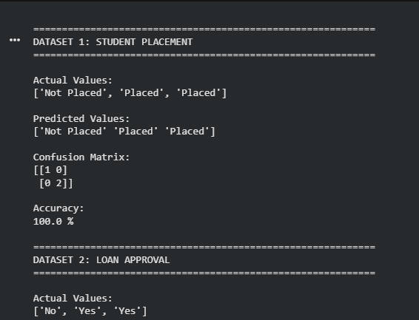
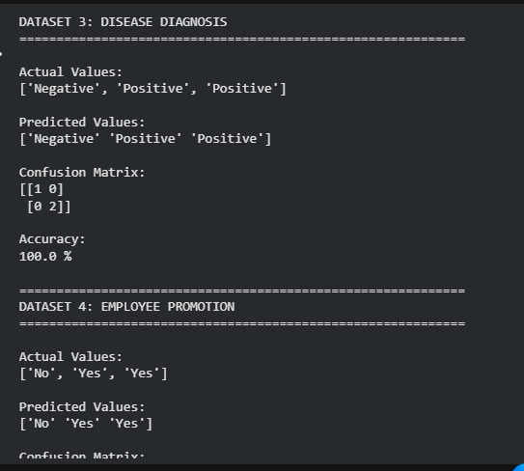
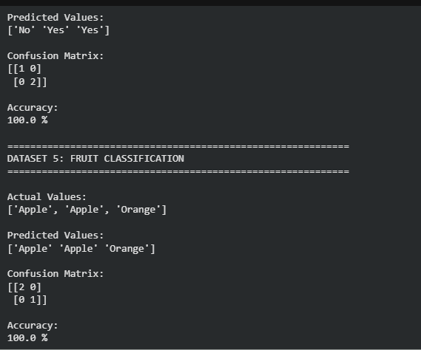

Result
The Gaussian Naïve Bayes algorithm was successfully implemented using GaussianNB. The datasets were divided into training and testing sets, class labels were predicted, and the performance was evaluated using the Confusion Matrix and Accuracy Score.

Experiment - 7
7. To implement Logistic Regression for binary classification.
Procedure
- Import the Logistic Regression model.
- Create the dataset and class labels.
- Train the model using the training data.
- Predict the class of a new sample.
- Display the predicted result.

Dataset 1: Student Placement Prediction
CGPA | Aptitude Score | Communication Score | Placement
9.2 | 90 | 88 | 1
8.8 | 85 | 84 | 1
8.5 | 82 | 80 | 1
7.2 | 72 | 70 | 0
6.8 | 68 | 65 | 0
9.0 | 91 | 89 | 1
7.0 | 70 | 68 | 0
8.7 | 86 | 83 | 1
6.5 | 65 | 60 | 0
9.1 | 92 | 90 | 1

Target Variable
- 1 = Placed
- 0 = Not Placed

New Sample
CGPA | Aptitude Score | Communication Score
8.9 | 88 | 85

Dataset 2: Loan Approval Prediction
Income (₹ Lakhs) | Credit Score | Loan Amount (₹ Lakhs) | Loan Approved
8 | 780 | 5 | 1
7 | 760 | 4 | 1
6 | 730 | 5 | 1
4 | 620 | 8 | 0
3 | 590 | 9 | 0
9 | 810 | 4 | 1
5 | 650 | 7 | 0
8 | 770 | 5 | 1
4 | 610 | 8 | 0
7 | 750 | 6 | 1

Target Variable
- 1 = Approved
- 0 = Rejected

New Sample
Income | Credit Score | Loan Amount
7 | 760 | 5

Dataset 3: Disease Diagnosis
Temperature (°C) | Heart Rate (bpm) | Oxygen Level (%) | Disease
39.1 | 112 | 94 | 1
38.8 | 109 | 95 | 1
37.0 | 78 | 99 | 0
39.3 | 115 | 93 | 1
36.8 | 74 | 98 | 0
38.7 | 110 | 94 | 1
37.1 | 80 | 98 | 0
39.0 | 113 | 92 | 1
36.9 | 76 | 99 | 0
38.9 | 111 | 93 | 1

Target Variable
- 1 = Disease Present
- 0 = Disease Absent

New Sample
Temperature | Heart Rate | Oxygen Level
38.8 | 110 | 94

Dataset 4: Employee Promotion Prediction
Experience (Years) | Performance Score | Training Hours | Promotion
10 | 95 | 50 | 1
9 | 92 | 48 | 1
8 | 90 | 45 | 1
4 | 70 | 25 | 0
3 | 65 | 20 | 0
11 | 96 | 52 | 1
5 | 75 | 30 | 0
8 | 89 | 44 | 1
2 | 60 | 18 | 0
7 | 87 | 40 | 1

Target Variable
- 1 = Promoted
- 0 = Not Promoted

New Sample
Experience | Performance Score | Training Hours
8 | 91 | 46

Dataset 5: Customer Purchase Prediction
Age | Annual Income (₹ Lakhs) | Spending Score | Purchase
22 | 3 | 30 | 0
25 | 4 | 35 | 0
28 | 5 | 45 | 0
32 | 7 | 60 | 1
35 | 8 | 65 | 1
40 | 9 | 75 | 1
45 | 10 | 80 | 1
30 | 6 | 55 | 1
24 | 4 | 40 | 0
38 | 9 | 70 | 1

Target Variable
- 1 = Purchased
- 0 = Not Purchased

New Sample
Age | Annual Income | Spending Score
34 | 8 | 68

Procedure for Logistic Regression
For each dataset, follow these steps:
- Import the Logistic Regression model:
from sklearn.linear_model import LogisticRegression
- Create the feature matrix (X) and target labels (y).
- Split the dataset into training and testing sets:
- from sklearn.model_selection import train_test_split

- X_train, X_test, y_train, y_test = train_test_split(
- X, y, test_size=0.3, random_state=42
)
- Train the Logistic Regression model:
- model = LogisticRegression()
model.fit(X_train, y_train)
- Predict the class of a new sample:
prediction = model.predict(new_sample)
- Display the predicted result:
print("Predicted Class:", prediction)

Suggested CSV File Names
- student_placement_logistic.csv
- loan_approval_logistic.csv
- disease_diagnosis_logistic.csv
- employee_promotion_logistic.csv
- customer_purchase_logistic.csv
These datasets are appropriate for laboratory experiments using Logistic Regression for binary classification. They contain numerical features, making them directly compatible with Scikit-learn's LogisticRegression model without requiring categorical encoding.

Aim
To implement Logistic Regression for binary classification and predict the class of a new sample.

Procedure
- Import the LogisticRegression model.
- Create the feature dataset X and target labels y.
- Split the dataset into training and testing data.
- Standardize the feature values.
- Train the Logistic Regression model.
- Predict the class of the new sample.
- Display the predicted result.
Program:
from sklearn.linear_model import LogisticRegression
from sklearn.model_selection import train_test_split
from sklearn.preprocessing import StandardScaler

def logistic_prediction(
X,
y,
new_sample,
dataset_name,
positive_label,
negative_label
):

X_train, X_test, y_train, y_test = (
train_test_split(
X,
y,
test_size=0.3,
random_state=42,
stratify=y
)
)

scaler = StandardScaler()

X_train = scaler.fit_transform(
X_train
)

X_test = scaler.transform(
X_test
)

new_sample = scaler.transform(
[new_sample]
)

model = LogisticRegression(
random_state=42,
max_iter=1000
)

model.fit(
X_train,
y_train
)

prediction = model.predict(
new_sample
)[0]

probability = model.predict_proba(
new_sample
)[0][1]

if prediction == 1:

result = positive_label

else:

result = negative_label

print("\n" + "=" * 60)

print(dataset_name)

print("=" * 60)

print("\nPredicted Class:")

print(prediction)

print("\nPredicted Result:")

print(result)

print("\nProbability of Class 1:")

print(
round(
probability * 100,
2
),
"%"
)

student_X = [
[9.2, 90, 88],
[8.8, 85, 84],
[8.5, 82, 80],
[7.2, 72, 70],
[6.8, 68, 65],
[9.0, 91, 89],
[7.0, 70, 68],
[8.7, 86, 83],
[6.5, 65, 60],
[9.1, 92, 90]
]

student_y = [
1,
1,
1,
0,
0,
1,
0,
1,
0,
1
]

new_student = [
8.9,
88,
85
]

loan_X = [
[8, 780, 5],
[7, 760, 4],
[6, 730, 5],
[4, 620, 8],
[3, 590, 9],
[9, 810, 4],
[5, 650, 7],
[8, 770, 5],
[4, 610, 8],
[7, 750, 6]
]

loan_y = [
1,
1,
1,
0,
0,
1,
0,
1,
0,
1
]

new_loan = [
7,
760,
5
]

disease_X = [
[39.1, 112, 94],
[38.8, 109, 95],
[37.0, 78, 99],
[39.3, 115, 93],
[36.8, 74, 98],
[38.7, 110, 94],
[37.1, 80, 98],
[39.0, 113, 92],
[36.9, 76, 99],
[38.9, 111, 93]
]

disease_y = [
1,
1,
0,
1,
0,
1,
0,
1,
0,
1
]

new_disease = [
38.8,
110,
94
]

employee_X = [
[10, 95, 50],
[9, 92, 48],
[8, 90, 45],
[4, 70, 25],
[3, 65, 20],
[11, 96, 52],
[5, 75, 30],
[8, 89, 44],
[2, 60, 18],
[7, 87, 40]
]

employee_y = [
1,
1,
1,
0,
0,
1,
0,
1,
0,
1
]

new_employee = [
8,
91,
46
]

customer_X = [
[22, 3, 30],
[25, 4, 35],
[28, 5, 45],
[32, 7, 60],
[35, 8, 65],
[40, 9, 75],
[45, 10, 80],
[30, 6, 55],
[24, 4, 40],
[38, 9, 70]
]

customer_y = [
0,
0,
0,
1,
1,
1,
1,
1,
0,
1
]

new_customer = [
34,
8,
68
]

logistic_prediction(
student_X,
student_y,
new_student,
"DATASET 1: STUDENT PLACEMENT",
"Placed",
"Not Placed"
)

logistic_prediction(
loan_X,
loan_y,
new_loan,
"DATASET 2: LOAN APPROVAL",
"Approved",
"Rejected"
)

logistic_prediction(
disease_X,
disease_y,
new_disease,
"DATASET 3: DISEASE DIAGNOSIS",
"Disease Present",
"Disease Absent"
)

logistic_prediction(
employee_X,
employee_y,
new_employee,
"DATASET 4: EMPLOYEE PROMOTION",
"Promoted",
"Not Promoted"
)

logistic_prediction(
customer_X,
customer_y,
new_customer,
"DATASET 5: CUSTOMER PURCHASE",
"Purchased",
"Not Purchased"
)
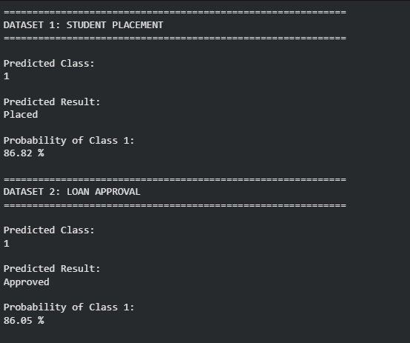
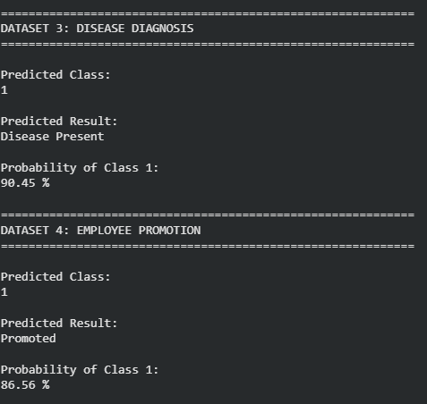
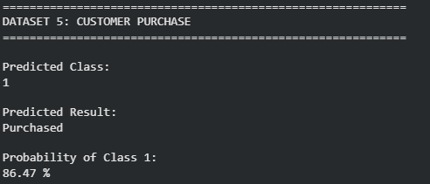

Result
The Logistic Regression algorithm was successfully implemented for binary classification. The model was trained using the given numerical datasets and successfully predicted the class of each new sample.
Experiment - 8
8. To implement Linear Regression for prediction.
Procedure
- Import the Linear Regression model.
- Create the dataset and target values.
- Train the model using the training data.
- Predict a new value.
- Display the predicted result.

Dataset 1: House Price Prediction
House Size (sq.ft) | Bedrooms | House Age (Years) | Price (₹ Lakhs)
800 | 2 | 10 | 35
1000 | 2 | 8 | 45
1200 | 3 | 6 | 55
1400 | 3 | 5 | 65
1600 | 4 | 4 | 75
1800 | 4 | 3 | 85
2000 | 5 | 2 | 95
2200 | 5 | 1 | 105
2400 | 6 | 1 | 115
2600 | 6 | 0 | 125

Target Variable
House Price (₹ Lakhs)

New Sample
House Size | Bedrooms | House Age
1700 | 4 | 3

Dataset 2: Student Marks Prediction
Study Hours | Attendance (%) | Assignment Score | Final Marks
2 | 70 | 60 | 55
3 | 75 | 65 | 60
4 | 80 | 70 | 68
5 | 82 | 75 | 74
6 | 85 | 80 | 80
7 | 88 | 85 | 86
8 | 90 | 90 | 91
9 | 92 | 94 | 95
10 | 95 | 96 | 98
11 | 97 | 98 | 100

Target Variable
Final Marks

New Sample
Study Hours | Attendance | Assignment Score
7 | 90 | 88

Dataset 3: Employee Salary Prediction
Experience (Years) | Education Level (Years) | Skill Score | Salary (₹ Lakhs)
1 | 15 | 60 | 3.5
2 | 15 | 65 | 4.2
3 | 16 | 70 | 5.1
4 | 16 | 75 | 6.0
5 | 17 | 80 | 7.2
6 | 17 | 82 | 8.0
7 | 18 | 85 | 9.1
8 | 18 | 88 | 10.0
9 | 18 | 90 | 11.2
10 | 19 | 94 | 12.5

Target Variable
Salary (₹ Lakhs)

New Sample
Experience | Education | Skill Score
7 | 18 | 86

Dataset 4: Car Fuel Efficiency Prediction
Engine Capacity (L) | Vehicle Weight (kg) | Speed (km/h) | Mileage (km/L)
1.0 | 900 | 60 | 24
1.2 | 950 | 70 | 22
1.4 | 1050 | 80 | 20
1.6 | 1150 | 90 | 18
1.8 | 1250 | 100 | 16
2.0 | 1350 | 110 | 15
2.2 | 1450 | 120 | 13
2.4 | 1550 | 130 | 12
2.6 | 1650 | 140 | 11
2.8 | 1750 | 150 | 10

Target Variable
Mileage (km/L)

New Sample
Engine Capacity | Weight | Speed
1.5 | 1100 | 85

Dataset 5: Sales Prediction
Advertising Cost (₹ Thousands) | Salespersons | Store Visits | Monthly Sales (₹ Lakhs)
10 | 2 | 120 | 3.5
15 | 3 | 150 | 4.5
20 | 4 | 180 | 5.8
25 | 5 | 210 | 7.0
30 | 6 | 240 | 8.2
35 | 7 | 260 | 9.5
40 | 8 | 280 | 10.8
45 | 9 | 300 | 12.0
50 | 10 | 320 | 13.5
55 | 11 | 340 | 15.0

Target Variable
Monthly Sales (₹ Lakhs)

New Sample
Advertising Cost | Salespersons | Store Visits
38 | 7 | 270

Procedure for Linear Regression
Use the following procedure for each dataset:
- Import the Linear Regression model:
from sklearn.linear_model import LinearRegression
- Create the feature matrix (X) and target values (y).
- Train the model:
- model = LinearRegression()
model.fit(X, y)
- Predict a new value:
prediction = model.predict(new_sample)
- Display the predicted result:
print("Predicted Value:", prediction)

Suggested CSV File Names
- house_price_linear.csv
- student_marks_linear.csv
- employee_salary_linear.csv
- car_mileage_linear.csv
- sales_prediction_linear.csv
These datasets are designed for Linear Regression laboratory exercises. They use continuous numerical target values and are suitable for demonstrating prediction tasks with Scikit-learn's LinearRegression model.

Aim
To implement the Linear Regression algorithm in Python and predict a continuous numerical value for a new sample.

Procedure
- Import the LinearRegression model.
- Create the feature matrix X and target values y.
- Create the Linear Regression model.
- Train the model using the training data.
- Predict the value for a new sample.
- Display the predicted result.
Program:
from sklearn.linear_model import LinearRegression

def linear_regression_prediction(
X,
y,
new_sample,
dataset_name,
unit
):

model = LinearRegression()

model.fit(
X,
y
)

prediction = model.predict(
[new_sample]
)[0]

print("\n" + "=" * 60)

print(dataset_name)

print("=" * 60)

print("\nNew Sample:")

print(new_sample)

print("\nPredicted Value:")

print(
round(
prediction,
2
),
unit
)

house_X = [
[800, 2, 10],
[1000, 2, 8],
[1200, 3, 6],
[1400, 3, 5],
[1600, 4, 4],
[1800, 4, 3],
[2000, 5, 2],
[2200, 5, 1],
[2400, 6, 1],
[2600, 6, 0]
]

house_y = [
35,
45,
55,
65,
75,
85,
95,
105,
115,
125
]

new_house = [
1700,
4,
3
]

student_X = [
[2, 70, 60],
[3, 75, 65],
[4, 80, 70],
[5, 82, 75],
[6, 85, 80],
[7, 88, 85],
[8, 90, 90],
[9, 92, 94],
[10, 95, 96],
[11, 97, 98]
]

student_y = [
55,
60,
68,
74,
80,
86,
91,
95,
98,
100
]

new_student = [
7,
90,
88
]

salary_X = [
[1, 15, 60],
[2, 15, 65],
[3, 16, 70],
[4, 16, 75],
[5, 17, 80],
[6, 17, 82],
[7, 18, 85],
[8, 18, 88],
[9, 18, 90],
[10, 19, 94]
]

salary_y = [
3.5,
4.2,
5.1,
6.0,
7.2,
8.0,
9.1,
10.0,
11.2,
12.5
]

new_salary = [
7,
18,
86
]

car_X = [
[1.0, 900, 60],
[1.2, 950, 70],
[1.4, 1050, 80],
[1.6, 1150, 90],
[1.8, 1250, 100],
[2.0, 1350, 110],
[2.2, 1450, 120],
[2.4, 1550, 130],
[2.6, 1650, 140],
[2.8, 1750, 150]
]

car_y = [
24,
22,
20,
18,
16,
15,
13,
12,
11,
10
]

new_car = [
1.5,
1100,
85
]

sales_X = [
[10, 2, 120],
[15, 3, 150],
[20, 4, 180],
[25, 5, 210],
[30, 6, 240],
[35, 7, 260],
[40, 8, 280],
[45, 9, 300],
[50, 10, 320],
[55, 11, 340]
]

sales_y = [
3.5,
4.5,
5.8,
7.0,
8.2,
9.5,
10.8,
12.0,
13.5,
15.0
]

new_sales = [
38,
7,
270
]

linear_regression_prediction(
house_X,
house_y,
new_house,
"DATASET 1: HOUSE PRICE PREDICTION",
"₹ Lakhs"
)

linear_regression_prediction(
student_X,
student_y,
new_student,
"DATASET 2: STUDENT MARKS PREDICTION",
"Marks"
)

linear_regression_prediction(
salary_X,
salary_y,
new_salary,
"DATASET 3: EMPLOYEE SALARY PREDICTION",
"₹ Lakhs"
)

linear_regression_prediction(
car_X,
car_y,
new_car,
"DATASET 4: CAR FUEL EFFICIENCY",
"km/L"
)

linear_regression_prediction(
sales_X,
sales_y,
new_sales,
"DATASET 5: SALES PREDICTION",
"₹ Lakhs"
)
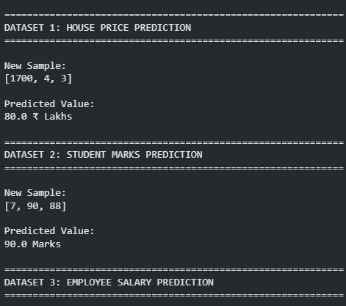
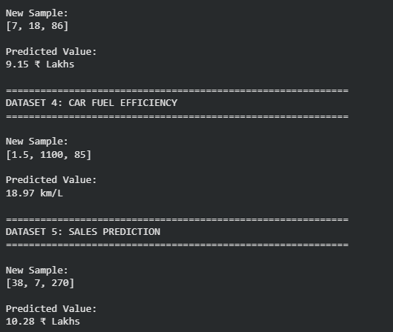

Result
The Linear Regression algorithm was successfully implemented using Scikit-learn’s LinearRegression model. The model was trained using the given numerical datasets and successfully predicted continuous values for the new samples.

Experiment - 9
9. To compare Linear Regression and Polynomial Regression using Python.
Procedure
- Import Linear Regression and Polynomial Features.
- Create the dataset.
- Apply Linear Regression and predict values.
- Transform the data using Polynomial Features.
- Apply Polynomial Regression and predict values.
Compare the results.

Dataset 1: House Price Prediction
House Size (sq.ft) | House Price (₹ Lakhs)
800 | 32
1000 | 40
1200 | 52
1400 | 68
1600 | 88
1800 | 112
2000 | 140
2200 | 172
2400 | 208
2600 | 248

Target Variable
House Price (₹ Lakhs)

New Sample
House Size
1700

Dataset 2: Student Study Hours vs Marks
Study Hours | Marks (%)
1 | 18
2 | 30
3 | 43
4 | 57
5 | 68
6 | 78
7 | 86
8 | 92
9 | 96
10 | 98

Target Variable
Marks (%)

New Sample
Study Hours
7.5

Dataset 3: Car Speed vs Fuel Consumption
Speed (km/h) | Fuel Consumption (L/100 km)
40 | 4.5
50 | 4.8
60 | 5.2
70 | 5.9
80 | 6.8
90 | 8.0
100 | 9.5
110 | 11.2
120 | 13.4
130 | 16.0

Target Variable
Fuel Consumption (L/100 km)

New Sample
Speed
95

Dataset 4: Advertising Cost vs Sales
Advertising Cost (₹ Thousands) | Sales (₹ Lakhs)
5 | 1.2
10 | 2.5
15 | 4.1
20 | 6.2
25 | 8.8
30 | 11.9
35 | 15.5
40 | 19.6
45 | 24.2
50 | 29.3

Target Variable
Sales (₹ Lakhs)

New Sample
Advertising Cost
32

Dataset 5: Years of Experience vs Salary
Experience (Years) | Salary (₹ Lakhs)
1 | 3.0
2 | 3.8
3 | 4.9
4 | 6.3
5 | 8.0
6 | 10.2
7 | 12.9
8 | 16.1
9 | 19.8
10 | 24.0

Target Variable
Salary (₹ Lakhs)

New Sample
Experience
7.5

Procedure for Comparing Linear and Polynomial Regression
Use the following procedure for each dataset:

Step 1: Import the Required Libraries
from sklearn.linear_model import LinearRegression
from sklearn.preprocessing import PolynomialFeatures

Step 2: Create the Dataset
Separate the data into:
- Feature matrix (X)
- Target values (y)

Step 3: Apply Linear Regression
linear_model = LinearRegression()
linear_model.fit(X, y)

linear_prediction = linear_model.predict(new_sample)

Step 4: Transform the Data Using Polynomial Features
poly = PolynomialFeatures(degree=2)

X_poly = poly.fit_transform(X)

new_sample_poly = poly.transform(new_sample)

Step 5: Apply Polynomial Regression
poly_model = LinearRegression()

poly_model.fit(X_poly, y)

poly_prediction = poly_model.predict(new_sample_poly)

Step 6: Compare the Results
Display both predictions:
print("Linear Regression Prediction :", linear_prediction)

print("Polynomial Regression Prediction :", poly_prediction)
You can also compare the models using:
- Mean Squared Error (MSE)
- R² Score (Coefficient of Determination)
- Prediction Accuracy
- Graphical Comparison (Regression Curves)

Suggested CSV File Names
- house_price_regression.csv
- student_marks_regression.csv
- car_fuel_regression.csv
- advertising_sales_regression.csv
- experience_salary_regression.csv
These datasets are suitable for laboratory experiments that compare Linear Regression and Polynomial Regression, helping students understand how polynomial features improve predictions for nonlinear relationships.

Aim
To implement and compare Linear Regression and Polynomial Regression using Python, and evaluate their predictions using Mean Squared Error (MSE) and R² Score.

Procedure
- Import LinearRegression and PolynomialFeatures.
- Create the input dataset X and target values y.
- Train the Linear Regression model.
- Predict the value of the new sample using Linear Regression.
- Transform the input data using Polynomial Features with degree 2.
- Train the Polynomial Regression model.
- Predict the value of the new sample using Polynomial Regression.
- Calculate and compare the MSE and R² scores.
- Display the predictions and performance results.
Program:
import numpy as np

from sklearn.linear_model import LinearRegression

from sklearn.preprocessing import PolynomialFeatures

from sklearn.metrics import mean_squared_error

from sklearn.metrics import r2_score

def compare_regression(
X,
y,
new_sample,
dataset_name,
unit
):

X = np.array(X)

y = np.array(y)

new_sample = np.array(
[[new_sample]]
)

linear_model = LinearRegression()

linear_model.fit(
X,
y
)

linear_prediction = (
linear_model.predict(
new_sample
)[0]
)

linear_training_prediction = (
linear_model.predict(
X
)
)

linear_mse = mean_squared_error(
y,
linear_training_prediction
)

linear_r2 = r2_score(
y,
linear_training_prediction
)

poly = PolynomialFeatures(
degree=2
)

X_poly = poly.fit_transform(
X
)

new_sample_poly = poly.transform(
new_sample
)

polynomial_model = LinearRegression()

polynomial_model.fit(
X_poly,
y
)

polynomial_prediction = (
polynomial_model.predict(
new_sample_poly
)[0]
)

polynomial_training_prediction = (
polynomial_model.predict(
X_poly
)
)

polynomial_mse = mean_squared_error(
y,
polynomial_training_prediction
)

polynomial_r2 = r2_score(
y,
polynomial_training_prediction
)

print(
"\n" + "=" * 65
)

print(
dataset_name
)

print(
"=" * 65
)

print(
"\nNew Sample:"
)

print(
new_sample[0][0]
)

print(
"\nLinear Regression Prediction:"
)

print(
round(
linear_prediction,
2
),
unit
)

print(
"\nPolynomial Regression Prediction:"
)

print(
round(
polynomial_prediction,
2
),
unit
)

print(
"\nLinear Regression MSE:"
)

print(
round(
linear_mse,
4
)
)

print(
"\nPolynomial Regression MSE:"
)

print(
round(
polynomial_mse,
4
)
)

print(
"\nLinear Regression R2 Score:"
)

print(
round(
linear_r2,
4
)
)

print(
"\nPolynomial Regression R2 Score:"
)

print(
round(
polynomial_r2,
4
)
)

house_X = [
[800],
[1000],
[1200],
[1400],
[1600],
[1800],
[2000],
[2200],
[2400],
[2600]
]

house_y = [
32,
40,
52,
68,
88,
112,
140,
172,
208,
248
]

student_X = [
[1],
[2],
[3],
[4],
[5],
[6],
[7],
[8],
[9],
[10]
]

student_y = [
18,
30,
43,
57,
68,
78,
86,
92,
96,
98
]

car_X = [
[40],
[50],
[60],
[70],
[80],
[90],
[100],
[110],
[120],
[130]
]

car_y = [
4.5,
4.8,
5.2,
5.9,
6.8,
8.0,
9.5,
11.2,
13.4,
16.0
]

advertising_X = [
[5],
[10],
[15],
[20],
[25],
[30],
[35],
[40],
[45],
[50]
]

advertising_y = [
1.2,
2.5,
4.1,
6.2,
8.8,
11.9,
15.5,
19.6,
24.2,
29.3
]

experience_X = [
[1],
[2],
[3],
[4],
[5],
[6],
[7],
[8],
[9],
[10]
]

experience_y = [
3.0,
3.8,
4.9,
6.3,
8.0,
10.2,
12.9,
16.1,
19.8,
24.0
]

compare_regression(
house_X,
house_y,
1700,
"DATASET 1: HOUSE PRICE PREDICTION",
"₹ Lakhs"
)

compare_regression(
student_X,
student_y,
7.5,
"DATASET 2: STUDY HOURS VS MARKS",
"%"
)

compare_regression(
car_X,
car_y,
95,
"DATASET 3: CAR SPEED VS FUEL CONSUMPTION",
"L/100 km"
)

compare_regression(
advertising_X,
advertising_y,
32,
"DATASET 4: ADVERTISING COST VS SALES",
"₹ Lakhs"
)

compare_regression(
experience_X,
experience_y,
7.5,
"DATASET 5: EXPERIENCE VS SALARY",
"₹ Lakhs"
)
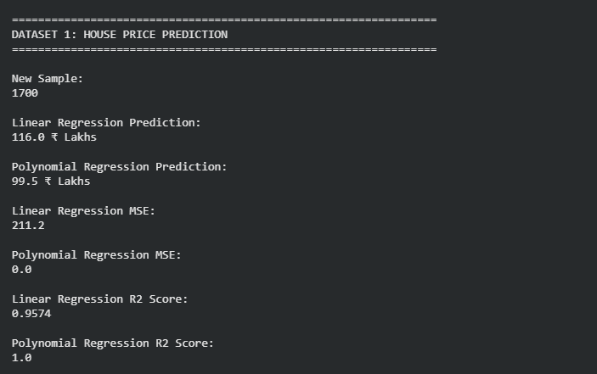
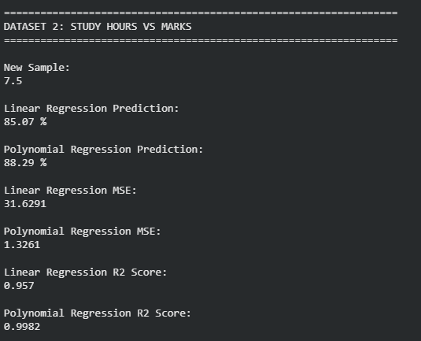

Result
Linear Regression and Polynomial Regression were successfully implemented and compared. The predictions, Mean Squared Error, and R² scores were displayed for all five datasets. Polynomial Regression generally provided a better fit because the datasets contain nonlinear relationships.
Experiment - 10
10. To implement the Expectation Maximization (EM) algorithm for clustering data.
Procedure
- Import the Gaussian Mixture Model.
- Create the dataset.
- Train the EM model.
- Predict the cluster labels.
- Display the clustering result.

Dataset 1: Student Performance Clustering
Study Hours | Attendance (%)
2 | 65
3 | 70
4 | 75
5 | 80
6 | 85
7 | 88
8 | 90
9 | 93
10 | 95
11 | 98

New Sample
Study Hours | Attendance
7 | 89

Dataset 2: Customer Segmentation
Annual Income (₹ Lakhs) | Spending Score
2 | 20
3 | 25
4 | 30
5 | 40
6 | 50
8 | 65
10 | 75
12 | 82
14 | 90
16 | 96

New Sample
Income | Spending Score
9 | 70

Dataset 3: House Size Clustering
House Size (sq.ft) | Price (₹ Lakhs)
800 | 30
900 | 35
1000 | 40
1200 | 50
1400 | 60
1600 | 75
1800 | 90
2000 | 105
2200 | 120
2400 | 135

New Sample
House Size | Price
1700 | 82

Dataset 4: Employee Salary Analysis
Experience (Years) | Salary (₹ Lakhs)
1 | 3.0
2 | 3.8
3 | 4.8
4 | 6.0
5 | 7.5
6 | 9.0
7 | 10.8
8 | 12.6
9 | 14.5
10 | 16.5

New Sample
Experience | Salary
7 | 11.0

Dataset 5: Vehicle Speed Analysis
Speed (km/h) | Fuel Consumption (L/100 km)
40 | 4.5
50 | 5.0
60 | 5.6
70 | 6.5
80 | 7.8
90 | 9.2
100 | 10.8
110 | 12.5
120 | 14.3
130 | 16.2

New Sample
Speed | Fuel Consumption
95 | 10.0

Procedure for Expectation Maximization (EM) Algorithm
Use the following procedure for each dataset.

Step 1: Import the Gaussian Mixture Model
from sklearn.mixture import GaussianMixture

Step 2: Create the Dataset
Separate the numerical features into a feature matrix:
X = dataset

Step 3: Create and Train the EM Model
gmm = GaussianMixture(
n_components=2,
random_state=42
)

gmm.fit(X)

Step 4: Predict the Cluster Labels
clusters = gmm.predict(X)

Step 5: Predict the Cluster for a New Sample
new_cluster = gmm.predict(new_sample)

Step 6: Display the Results
print("Cluster Labels:")
print(clusters)

print("New Sample Cluster:")
print(new_cluster)

Suggested CSV File Names
- student_performance_em.csv
- customer_segmentation_em.csv
- house_price_em.csv
- employee_salary_em.csv
- vehicle_speed_em.csv
These datasets are suitable for laboratory experiments using the Expectation Maximization (EM) algorithm with Gaussian Mixture Models (GMM). They enable students to perform unsupervised clustering, assign cluster labels, and classify new samples into the learned clusters.

Aim
To implement the Expectation Maximization (EM) algorithm using a Gaussian Mixture Model (GMM) and cluster the given data into two groups.

Procedure
- Import GaussianMixture.
- Create the numerical dataset.
- Standardize the dataset.
- Create the Gaussian Mixture Model with n_components=2.
- Train the EM model using the dataset.
- Predict the cluster labels for all data points.
- Predict the cluster of the new sample.
- Display the clustering results.
Program:
import numpy as np

from sklearn.mixture import GaussianMixture

from sklearn.preprocessing import StandardScaler

def em_clustering(
X,
new_sample,
dataset_name
):

X = np.array(X)

new_sample = np.array(
[new_sample]
)

scaler = StandardScaler()

X_scaled = scaler.fit_transform(
X
)

new_sample_scaled = scaler.transform(
new_sample
)

gmm = GaussianMixture(
n_components=2,
random_state=42
)

gmm.fit(
X_scaled
)

clusters = gmm.predict(
X_scaled
)

new_cluster = gmm.predict(
new_sample_scaled
)

probabilities = gmm.predict_proba(
new_sample_scaled
)

print(
"\n" + "=" * 60
)

print(
dataset_name
)

print(
"=" * 60
)

print(
"\nCluster Labels:"
)

print(
clusters
)

print(
"\nNew Sample:"
)

print(
new_sample[0]
)

print(
"\nNew Sample Cluster:"
)

print(
new_cluster[0]
)

print(
"\nCluster Probabilities:"
)

print(
np.round(
probabilities[0],
4
)
)

student_X = [
[2, 65],
[3, 70],
[4, 75],
[5, 80],
[6, 85],
[7, 88],
[8, 90],
[9, 93],
[10, 95],
[11, 98]
]

new_student = [
7,
89
]

customer_X = [
[2, 20],
[3, 25],
[4, 30],
[5, 40],
[6, 50],
[8, 65],
[10, 75],
[12, 82],
[14, 90],
[16, 96]
]

new_customer = [
9,
70
]

house_X = [
[800, 30],
[900, 35],
[1000, 40],
[1200, 50],
[1400, 60],
[1600, 75],
[1800, 90],
[2000, 105],
[2200, 120],
[2400, 135]
]

new_house = [
1700,
82
]

employee_X = [
[1, 3.0],
[2, 3.8],
[3, 4.8],
[4, 6.0],
[5, 7.5],
[6, 9.0],
[7, 10.8],
[8, 12.6],
[9, 14.5],
[10, 16.5]
]

new_employee = [
7,
11.0
]

vehicle_X = [
[40, 4.5],
[50, 5.0],
[60, 5.6],
[70, 6.5],
[80, 7.8],
[90, 9.2],
[100, 10.8],
[110, 12.5],
[120, 14.3],
[130, 16.2]
]

new_vehicle = [
95,
10.0
]

em_clustering(
student_X,
new_student,
"DATASET 1: STUDENT PERFORMANCE"
)

em_clustering(
customer_X,
new_customer,
"DATASET 2: CUSTOMER SEGMENTATION"
)

em_clustering(
house_X,
new_house,
"DATASET 3: HOUSE SIZE CLUSTERING"
)

em_clustering(
employee_X,
new_employee,
"DATASET 4: EMPLOYEE SALARY ANALYSIS"
)

em_clustering(
vehicle_X,
new_vehicle,
"DATASET 5: VEHICLE SPEED ANALYSIS"
)
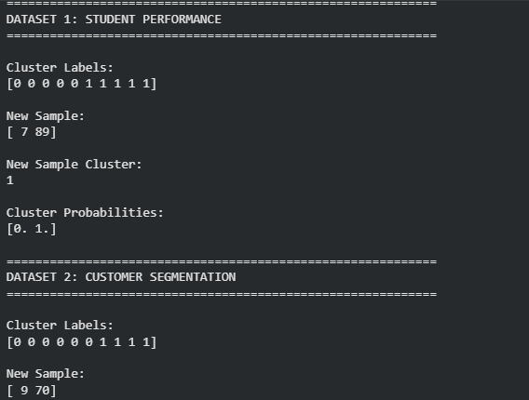
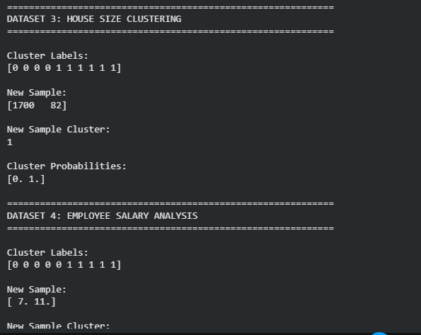

Result
The Expectation Maximization algorithm was successfully implemented using Scikit-learn’s GaussianMixture model. The data was divided into two clusters, and the cluster membership of each new sample was successfully predicted.
Experiment - 11
11. To classify credit scores using the Decision Tree algorithm.
Procedure
- Import the Decision Tree Classifier.
- Create the dataset and class labels.
- Train the model using the training data.
- Predict the credit score category.
- Display the predicted result.

Dataset 1: Customer Loan Profile
Annual Income (₹ Lakhs) | Credit History (Years) | Existing Loans | EMI Paid on Time | Credit Score
12 | 10 | 1 | Yes | Excellent
10 | 8 | 2 | Yes | Good
8 | 6 | 2 | Yes | Good
6 | 4 | 3 | No | Average
4 | 2 | 4 | No | Poor
15 | 12 | 1 | Yes | Excellent
7 | 5 | 3 | Yes | Average
5 | 3 | 4 | No | Poor
11 | 9 | 2 | Yes | Good
3 | 1 | 5 | No | Poor

Target Variable
Credit Score: Excellent, Good, Average, Poor

New Sample
Annual Income | Credit History | Existing Loans | EMI Paid on Time
9 | 7 | 2 | Yes

Dataset 2: Bank Customer Credit Rating
Monthly Income (₹) | Age | Loan Amount (₹ Lakhs) | Loan Default | Credit Score
90000 | 45 | 5 | No | Excellent
75000 | 40 | 6 | No | Good
60000 | 35 | 8 | No | Good
45000 | 30 | 10 | Yes | Average
30000 | 25 | 12 | Yes | Poor
95000 | 48 | 4 | No | Excellent
65000 | 37 | 7 | No | Good
40000 | 28 | 9 | Yes | Average
28000 | 24 | 13 | Yes | Poor
85000 | 43 | 5 | No | Excellent

Target Variable
Credit Score

New Sample
Monthly Income | Age | Loan Amount | Loan Default
70000 | 38 | 6 | No

Dataset 3: Credit Card Customer Analysis
Credit Limit (₹ Lakhs) | Monthly Spending (₹) | Payment Delay (Days) | Credit Score
8 | 40000 | 0 | Excellent
7 | 35000 | 2 | Good
6 | 30000 | 4 | Good
5 | 25000 | 10 | Average
4 | 20000 | 20 | Poor
9 | 45000 | 0 | Excellent
6 | 28000 | 5 | Good
5 | 23000 | 12 | Average
3 | 18000 | 25 | Poor
8 | 42000 | 1 | Excellent

Target Variable
Credit Score

New Sample
Credit Limit | Monthly Spending | Payment Delay
7 | 36000 | 3

Dataset 4: Personal Finance Profile
Savings (₹ Lakhs) | Monthly Expenses (₹) | Outstanding Debt (₹ Lakhs) | Credit Score
10 | 30000 | 1 | Excellent
8 | 35000 | 2 | Good
6 | 40000 | 3 | Good
4 | 45000 | 5 | Average
2 | 50000 | 7 | Poor
11 | 28000 | 1 | Excellent
7 | 36000 | 2 | Good
5 | 43000 | 4 | Average
3 | 48000 | 6 | Poor
9 | 32000 | 1 | Excellent

Target Variable
Credit Score

New Sample
Savings | Monthly Expenses | Outstanding Debt
7 | 34000 | 2

Dataset 5: Home Loan Eligibility
Salary (₹ Lakhs) | CIBIL Score | Existing EMIs | Loan Status | Credit Score
15 | 850 | 1 | Approved | Excellent
12 | 800 | 2 | Approved | Good
10 | 760 | 2 | Approved | Good
8 | 700 | 3 | Pending | Average
6 | 620 | 4 | Rejected | Poor
16 | 880 | 1 | Approved | Excellent
11 | 780 | 2 | Approved | Good
7 | 680 | 3 | Pending | Average
5 | 600 | 5 | Rejected | Poor
14 | 830 | 1 | Approved | Excellent

Target Variable
Credit Score

New Sample
Salary | CIBIL Score | Existing EMIs | Loan Status
11 | 790 | 2 | Approved

Procedure for Decision Tree Credit Score Classification
Use the following procedure for each dataset.

Step 1: Import the Decision Tree Classifier
from sklearn.tree import DecisionTreeClassifier
from sklearn.preprocessing import LabelEncoder

Step 2: Create the Dataset and Class Labels
Separate the data into:
- Input Features (X)
- Target Labels (y)
Convert categorical attributes (such as Yes/No, Approved/Rejected) into numerical values using LabelEncoder.

Step 3: Train the Decision Tree Model
model = DecisionTreeClassifier(
criterion="entropy",
random_state=42
)

model.fit(X, y)

Step 4: Predict the Credit Score Category
prediction = model.predict(new_sample)

Step 5: Display the Predicted Result
print("Predicted Credit Score:", prediction)

Suggested CSV File Names
- customer_loan_credit_score.csv
- bank_customer_credit_rating.csv
- credit_card_customer.csv
- personal_finance_credit.csv
- home_loan_credit_score.csv
These datasets are suitable for Decision Tree-based Credit Score Classification laboratory experiments. They demonstrate how multiple financial attributes can be used to classify customers into credit score categories such as Excellent, Good, Average, and Poor

Aim
To implement the Decision Tree algorithm using Python and classify customers into the following credit score categories:
- Excellent
- Good
- Average
- Poor

Procedure
- Import DecisionTreeClassifier.
- Create the input dataset X and target labels y.
- Convert categorical values such as Yes/No and Approved/Pending/Rejected into numerical values.
- Create the Decision Tree model using the entropy criterion.
- Train the model using the given data.
- Predict the credit score category for the new sample.
- Display the predicted result.
Program:
from sklearn.tree import DecisionTreeClassifier

def credit_score_prediction(
X,
y,
new_sample,
dataset_name
):

model = DecisionTreeClassifier(
criterion="entropy",
random_state=42
)

model.fit(
X,
y
)

prediction = model.predict(
[new_sample]
)[0]

print("\n" + "=" * 65)

print(dataset_name)

print("=" * 65)

print("\nNew Customer Details:")

print(new_sample)

print("\nPredicted Credit Score:")

print(prediction)

customer_loan_X = [
[12, 10, 1, 1],
[10, 8, 2, 1],
[8, 6, 2, 1],
[6, 4, 3, 0],
[4, 2, 4, 0],
[15, 12, 1, 1],
[7, 5, 3, 1],
[5, 3, 4, 0],
[11, 9, 2, 1],
[3, 1, 5, 0]
]

customer_loan_y = [
"Excellent",
"Good",
"Good",
"Average",
"Poor",
"Excellent",
"Average",
"Poor",
"Good",
"Poor"
]

new_customer_loan = [
9,
7,
2,
1
]

bank_customer_X = [
[90000, 45, 5, 0],
[75000, 40, 6, 0],
[60000, 35, 8, 0],
[45000, 30, 10, 1],
[30000, 25, 12, 1],
[95000, 48, 4, 0],
[65000, 37, 7, 0],
[40000, 28, 9, 1],
[28000, 24, 13, 1],
[85000, 43, 5, 0]
]

bank_customer_y = [
"Excellent",
"Good",
"Good",
"Average",
"Poor",
"Excellent",
"Good",
"Average",
"Poor",
"Excellent"
]

new_bank_customer = [
70000,
38,
6,
0
]

credit_card_X = [
[8, 40000, 0],
[7, 35000, 2],
[6, 30000, 4],
[5, 25000, 10],
[4, 20000, 20],
[9, 45000, 0],
[6, 28000, 5],
[5, 23000, 12],
[3, 18000, 25],
[8, 42000, 1]
]

credit_card_y = [
"Excellent",
"Good",
"Good",
"Average",
"Poor",
"Excellent",
"Good",
"Average",
"Poor",
"Excellent"
]

new_credit_card = [
7,
36000,
3
]

personal_finance_X = [
[10, 30000, 1],
[8, 35000, 2],
[6, 40000, 3],
[4, 45000, 5],
[2, 50000, 7],
[11, 28000, 1],
[7, 36000, 2],
[5, 43000, 4],
[3, 48000, 6],
[9, 32000, 1]
]

personal_finance_y = [
"Excellent",
"Good",
"Good",
"Average",
"Poor",
"Excellent",
"Good",
"Average",
"Poor",
"Excellent"
]

new_personal_finance = [
7,
34000,
2
]

home_loan_X = [
[15, 850, 1, 2],
[12, 800, 2, 2],
[10, 760, 2, 2],
[8, 700, 3, 1],
[6, 620, 4, 0],
[16, 880, 1, 2],
[11, 780, 2, 2],
[7, 680, 3, 1],
[5, 600, 5, 0],
[14, 830, 1, 2]
]

home_loan_y = [
"Excellent",
"Good",
"Good",
"Average",
"Poor",
"Excellent",
"Good",
"Average",
"Poor",
"Excellent"
]

new_home_loan = [
11,
790,
2,
2
]

credit_score_prediction(
customer_loan_X,
customer_loan_y,
new_customer_loan,
"DATASET 1: CUSTOMER LOAN PROFILE"
)

credit_score_prediction(
bank_customer_X,
bank_customer_y,
new_bank_customer,
"DATASET 2: BANK CUSTOMER CREDIT RATING"
)

credit_score_prediction(
credit_card_X,
credit_card_y,
new_credit_card,
"DATASET 3: CREDIT CARD CUSTOMER ANALYSIS"
)

credit_score_prediction(
personal_finance_X,
personal_finance_y,
new_personal_finance,
"DATASET 4: PERSONAL FINANCE PROFILE"
)

credit_score_prediction(
home_loan_X,
home_loan_y,
new_home_loan,
"DATASET 5: HOME LOAN ELIGIBILITY"
)
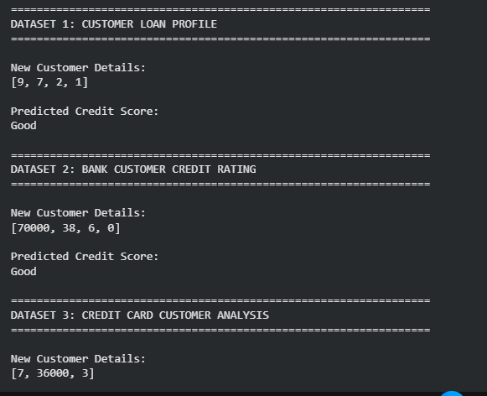
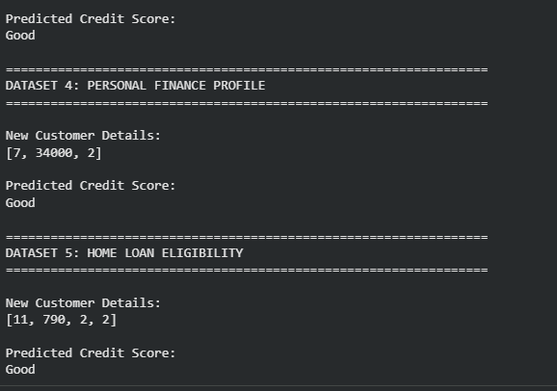

Result
The Decision Tree algorithm was successfully implemented using DecisionTreeClassifier with criterion="entropy". The model was trained using five credit-related datasets and successfully classified the new customer profiles.
12. To classify Iris flowers using the K-Nearest Neighbours (KNN) algorithm.
Procedure
- Import the Iris dataset and KNN classifier.
- Load the Iris dataset.
- Train the KNN model using the training data.
- Predict the flower class.
- Display the predicted result.

Dataset 1: Fruit Classification
Weight (g) | Diameter (cm) | Sweetness (%) | Fruit
150 | 7.5 | 90 | Apple
160 | 7.8 | 88 | Apple
145 | 7.3 | 91 | Apple
120 | 5.5 | 70 | Orange
125 | 5.8 | 72 | Orange
130 | 6.0 | 74 | Orange
155 | 7.6 | 89 | Apple
118 | 5.4 | 69 | Orange
148 | 7.4 | 92 | Apple
122 | 5.7 | 71 | Orange

Target Variable
Fruit: Apple / Orange

New Sample
Weight | Diameter | Sweetness
152 | 7.5 | 90

Dataset 2: Student Placement Classification
CGPA | Aptitude Score | Communication Score | Placement
9.2 | 90 | 88 | Placed
8.8 | 85 | 82 | Placed
8.5 | 80 | 79 | Placed
7.2 | 72 | 70 | Not Placed
6.8 | 68 | 65 | Not Placed
9.0 | 92 | 90 | Placed
7.5 | 75 | 74 | Not Placed
8.6 | 84 | 81 | Placed
6.5 | 60 | 58 | Not Placed
8.9 | 88 | 86 | Placed

Target Variable
Placement: Placed / Not Placed

New Sample
CGPA | Aptitude Score | Communication Score
8.7 | 86 | 84

Dataset 3: Disease Diagnosis
Temperature (°C) | Heart Rate (bpm) | Oxygen Level (%) | Disease
39.0 | 110 | 94 | Positive
38.5 | 108 | 95 | Positive
37.0 | 78 | 99 | Negative
39.2 | 115 | 93 | Positive
36.8 | 75 | 98 | Negative
38.8 | 112 | 94 | Positive
37.2 | 80 | 98 | Negative
39.1 | 114 | 92 | Positive
36.7 | 74 | 99 | Negative
38.9 | 111 | 93 | Positive

Target Variable
Disease: Positive / Negative

New Sample
Temperature | Heart Rate | Oxygen Level
38.7 | 109 | 94

Dataset 4: Employee Promotion Prediction
Experience (Years) | Performance Score | Training Hours | Promotion
10 | 95 | 50 | Promoted
8 | 90 | 45 | Promoted
7 | 88 | 40 | Promoted
3 | 65 | 20 | Not Promoted
2 | 60 | 18 | Not Promoted
9 | 93 | 48 | Promoted
4 | 70 | 25 | Not Promoted
8 | 89 | 42 | Promoted
2 | 58 | 15 | Not Promoted
6 | 85 | 38 | Promoted

Target Variable
Promotion: Promoted / Not Promoted

New Sample
Experience | Performance Score | Training Hours
7 | 90 | 44

Dataset 5: Vehicle Classification
Engine Capacity (cc) | Weight (kg) | Mileage (km/L) | Vehicle Type
100 | 95 | 70 | Bike
125 | 110 | 65 | Bike
150 | 125 | 55 | Bike
800 | 850 | 22 | Car
1000 | 950 | 20 | Car
1200 | 1050 | 18 | Car
110 | 100 | 68 | Bike
900 | 900 | 21 | Car
140 | 120 | 58 | Bike
1300 | 1100 | 17 | Car

Target Variable
Vehicle Type: Bike / Car

New Sample
Engine Capacity | Weight | Mileage
135 | 118 | 60

Procedure for K-Nearest Neighbours (KNN)
Use the following procedure for each dataset:

Step 1: Import the Required Libraries
from sklearn.neighbors import KNeighborsClassifier
from sklearn.model_selection import train_test_split

Step 2: Create the Dataset
Separate the data into:
- Feature Matrix (X)
- Target Labels (y)

Step 3: Split the Dataset
X_train, X_test, y_train, y_test = train_test_split(
X, y, test_size=0.3, random_state=42
)

Step 4: Train the KNN Model
knn = KNeighborsClassifier(n_neighbors=3)
knn.fit(X_train, y_train)

Step 5: Predict the Class
prediction = knn.predict(new_sample)

Step 6: Display the Predicted Result
print("Predicted Class:", prediction)

Suggested CSV File Names
- fruit_classification_knn.csv
- student_placement_knn.csv
- disease_diagnosis_knn.csv
- employee_promotion_knn.csv
- vehicle_classification_knn.csv
These datasets are suitable alternatives to the Iris dataset for demonstrating the K-Nearest Neighbours (KNN) algorithm. They use numerical features, making them directly compatible with Scikit-learn's KNeighborsClassifier, and provide practical real-world classification examples for machine learning laboratory exercises.

Aim
To implement and demonstrate the K-Nearest Neighbours (KNN) algorithm in Python and classify a new sample using K = 3.

Procedure
- Import the required libraries.
- Create the training dataset and target labels.
- Separate the input features as X and class labels as y.
- Split the dataset into training and testing data.
- Create the KNN model with n_neighbors=3.
- Train the model using the training data.
- Predict the class of the new sample.
- Display the predicted result and model accuracy.
Program:
import numpy as np

from sklearn.neighbors import KNeighborsClassifier

from sklearn.model_selection import train_test_split

from sklearn.preprocessing import StandardScaler

from sklearn.metrics import accuracy_score

def knn_classification(
X,
y,
new_sample,
dataset_name
):

X = np.array(X)

y = np.array(y)

new_sample = np.array(
[new_sample]
)

X_train, X_test, y_train, y_test = train_test_split(
X,
y,
test_size=0.3,
random_state=42,
stratify=y
)

scaler = StandardScaler()

X_train = scaler.fit_transform(
X_train
)

X_test = scaler.transform(
X_test
)

new_sample = scaler.transform(
new_sample
)

knn = KNeighborsClassifier(
n_neighbors=3
)

knn.fit(
X_train,
y_train
)

prediction = knn.predict(
new_sample
)[0]

y_pred = knn.predict(
X_test
)

accuracy = accuracy_score(
y_test,
y_pred
)

print(
"\n" + "=" * 65
)

print(
dataset_name
)

print(
"=" * 65
)

print(
"\nPredicted Class:"
)

print(
prediction
)

print(
"\nTesting Accuracy:"
)

print(
round(
accuracy * 100,
2
),
"%"
)

fruit_X = [
[150, 7.5, 90],
[160, 7.8, 88],
[145, 7.3, 91],
[120, 5.5, 70],
[125, 5.8, 72],
[130, 6.0, 74],
[155, 7.6, 89],
[118, 5.4, 69],
[148, 7.4, 92],
[122, 5.7, 71]
]

fruit_y = [
"Apple",
"Apple",
"Apple",
"Orange",
"Orange",
"Orange",
"Apple",
"Orange",
"Apple",
"Orange"
]

new_fruit = [
152,
7.5,
90
]

student_X = [
[9.2, 90, 88],
[8.8, 85, 82],
[8.5, 80, 79],
[7.2, 72, 70],
[6.8, 68, 65],
[9.0, 92, 90],
[7.5, 75, 74],
[8.6, 84, 81],
[6.5, 60, 58],
[8.9, 88, 86]
]

student_y = [
"Placed",
"Placed",
"Placed",
"Not Placed",
"Not Placed",
"Placed",
"Not Placed",
"Placed",
"Not Placed",
"Placed"
]

new_student = [
8.7,
86,
84
]

disease_X = [
[39.0, 110, 94],
[38.5, 108, 95],
[37.0, 78, 99],
[39.2, 115, 93],
[36.8, 75, 98],
[38.8, 112, 94],
[37.2, 80, 98],
[39.1, 114, 92],
[36.7, 74, 99],
[38.9, 111, 93]
]

disease_y = [
"Positive",
"Positive",
"Negative",
"Positive",
"Negative",
"Positive",
"Negative",
"Positive",
"Negative",
"Positive"
]

new_disease = [
38.7,
109,
94
]

employee_X = [
[10, 95, 50],
[8, 90, 45],
[7, 88, 40],
[3, 65, 20],
[2, 60, 18],
[9, 93, 48],
[4, 70, 25],
[8, 89, 42],
[2, 58, 15],
[6, 85, 38]
]

employee_y = [
"Promoted",
"Promoted",
"Promoted",
"Not Promoted",
"Not Promoted",
"Promoted",
"Not Promoted",
"Promoted",
"Not Promoted",
"Promoted"
]

new_employee = [
7,
90,
44
]

vehicle_X = [
[100, 95, 70],
[125, 110, 65],
[150, 125, 55],
[800, 850, 22],
[1000, 950, 20],
[1200, 1050, 18],
[110, 100, 68],
[900, 900, 21],
[140, 120, 58],
[1300, 1100, 17]
]

vehicle_y = [
"Bike",
"Bike",
"Bike",
"Car",
"Car",
"Car",
"Bike",
"Car",
"Bike",
"Car"
]

new_vehicle = [
135,
118,
60
]

knn_classification(
fruit_X,
fruit_y,
new_fruit,
"DATASET 1: FRUIT CLASSIFICATION"
)

knn_classification(
student_X,
student_y,
new_student,
"DATASET 2: STUDENT PLACEMENT"
)

knn_classification(
disease_X,
disease_y,
new_disease,
"DATASET 3: DISEASE DIAGNOSIS"
)

knn_classification(
employee_X,
employee_y,
new_employee,
"DATASET 4: EMPLOYEE PROMOTION"
)

knn_classification(
vehicle_X,
vehicle_y,
new_vehicle,
"DATASET 5: VEHICLE CLASSIFICATION"
)
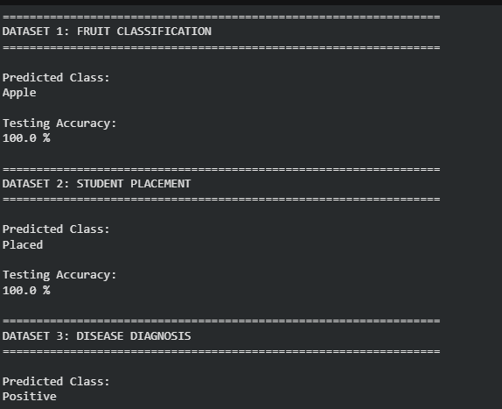
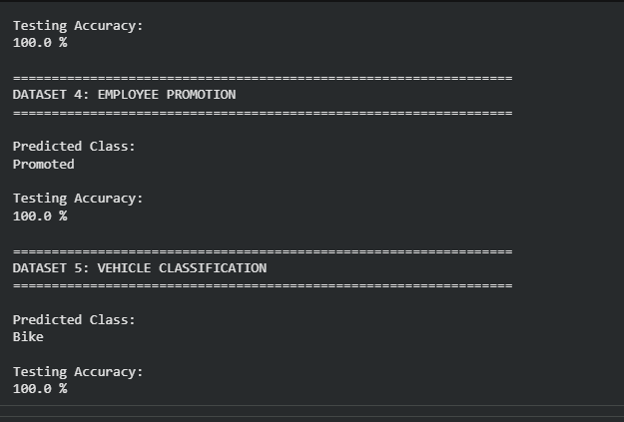

Result
The K-Nearest Neighbours (KNN) algorithm was successfully implemented using KNeighborsClassifier with K = 3. The model was trained using five datasets and successfully classified the given new samples.

13. To predict car prices using the Linear Regression algorithm.
Procedure
- Import the Linear Regression model.
- Create the dataset and target values.
- Train the model using the training data.
- Predict the car price for a new input.
- Display the predicted result.

Dataset 1: Basic Car Price Prediction
Car Age (Years) | Mileage (km) | Engine Size (cc) | Price (₹ Lakhs)
1 | 12000 | 1200 | 8.5
2 | 18000 | 1200 | 8.0
3 | 25000 | 1300 | 7.4
4 | 35000 | 1400 | 6.8
5 | 45000 | 1500 | 6.1
6 | 55000 | 1500 | 5.5
7 | 65000 | 1600 | 5.0
8 | 75000 | 1600 | 4.5
9 | 85000 | 1800 | 4.0
10 | 95000 | 1800 | 3.5

Target Variable
Car Price (₹ Lakhs)

New Sample
Car Age | Mileage | Engine Size
4 | 38000 | 1400

Dataset 2: Used Car Price Prediction
Manufacturing Year | Mileage (km) | Fuel Efficiency (km/L) | Price (₹ Lakhs)
2024 | 10000 | 22 | 10.5
2023 | 18000 | 21 | 9.8
2022 | 25000 | 20 | 9.0
2021 | 35000 | 19 | 8.2
2020 | 45000 | 18 | 7.5
2019 | 55000 | 17 | 6.8
2018 | 65000 | 16 | 6.0
2017 | 75000 | 15 | 5.4
2016 | 85000 | 14 | 4.8
2015 | 95000 | 13 | 4.2

Target Variable
Car Price (₹ Lakhs)

New Sample
Manufacturing Year | Mileage | Fuel Efficiency
2021 | 32000 | 19

Dataset 3: Sedan Car Price Prediction
Engine Capacity (cc) | Horsepower | Mileage (km) | Price (₹ Lakhs)
1000 | 70 | 10000 | 6.5
1200 | 82 | 15000 | 7.4
1400 | 95 | 22000 | 8.8
1500 | 105 | 30000 | 9.8
1600 | 115 | 38000 | 10.5
1800 | 130 | 45000 | 11.8
2000 | 145 | 52000 | 13.2
2200 | 160 | 60000 | 14.5
2400 | 175 | 68000 | 15.8
2600 | 190 | 76000 | 17.2

Target Variable
Car Price (₹ Lakhs)

New Sample
Engine Capacity | Horsepower | Mileage
1700 | 120 | 42000

Dataset 4: SUV Price Prediction
Engine Capacity (cc) | Vehicle Age (Years) | Distance Travelled (km) | Price (₹ Lakhs)
1500 | 1 | 12000 | 15.5
1800 | 2 | 20000 | 14.8
2000 | 3 | 28000 | 13.9
2200 | 4 | 36000 | 13.0
2400 | 5 | 44000 | 12.0
2600 | 6 | 52000 | 11.0
2800 | 7 | 60000 | 10.2
3000 | 8 | 68000 | 9.4
3200 | 9 | 76000 | 8.7
3400 | 10 | 84000 | 8.0

Target Variable
Car Price (₹ Lakhs)

New Sample
Engine Capacity | Vehicle Age | Distance Travelled
2100 | 4 | 34000

Dataset 5: Electric Car Price Prediction
Battery Capacity (kWh) | Range (km) | Charging Time (Hours) | Price (₹ Lakhs)
30 | 250 | 8 | 10.5
35 | 300 | 8 | 12.0
40 | 350 | 7 | 14.0
45 | 400 | 7 | 16.5
50 | 450 | 6 | 18.5
55 | 500 | 6 | 21.0
60 | 550 | 5 | 24.0
65 | 600 | 5 | 27.5
70 | 650 | 4 | 31.0
75 | 700 | 4 | 35.0

Target Variable
Car Price (₹ Lakhs)

New Sample
Battery Capacity | Range | Charging Time
52 | 470 | 6

Procedure for Linear Regression (Car Price Prediction)
Use the following procedure for each dataset.

Step 1: Import the Linear Regression Model
from sklearn.linear_model import LinearRegression

Step 2: Create the Dataset
Separate the data into:
- Input Features (X)
- Target Values (y)

Step 3: Train the Model
model = LinearRegression()
model.fit(X, y)

Step 4: Predict the Car Price for a New Input
prediction = model.predict(new_sample)

Step 5: Display the Predicted Result
print("Predicted Car Price:", prediction)

Suggested CSV File Names
- basic_car_price.csv
- used_car_price.csv
- sedan_car_price.csv
- suv_car_price.csv
- electric_car_price.csv
These datasets are suitable for undergraduate Machine Learning laboratory experiments on Linear Regression. They provide realistic numerical data for predicting car prices based on factors such as vehicle age, mileage, engine capacity, horsepower, battery capacity, and driving range, making them ideal for hands-on implementation using Scikit-learn

Aim
To implement the Linear Regression algorithm using Python and predict the price of a car based on features such as:
- Car age
- Mileage
- Engine capacity
- Manufacturing year
- Fuel efficiency
- Horsepower
- Battery capacity
- Driving range
- Charging time

Procedure
- Import the LinearRegression model.
- Create the input dataset X and target values y.
- Train the Linear Regression model.
- Provide a new car sample.
- Predict the car price.
- Display the predicted price.
Program:
import numpy as np

from sklearn.linear_model import LinearRegression

def car_price_prediction(
X,
y,
new_sample,
dataset_name
):

X = np.array(X)

y = np.array(y)

new_sample = np.array(
[new_sample]
)

model = LinearRegression()

model.fit(
X,
y
)

prediction = model.predict(
new_sample
)[0]

score = model.score(
X,
y
)

print(
"\n" + "=" * 65
)

print(
dataset_name
)

print(
"=" * 65
)

print(
"\nNew Car Details:"
)

print(
new_sample[0]
)

print(
"\nPredicted Car Price:"
)

print(
round(
prediction,
2
),
"Lakhs"
)

print(
"\nR² Score:"
)

print(
round(
score,
4
)
)

basic_car_X = [
[1, 12000, 1200],
[2, 18000, 1200],
[3, 25000, 1300],
[4, 35000, 1400],
[5, 45000, 1500],
[6, 55000, 1500],
[7, 65000, 1600],
[8, 75000, 1600],
[9, 85000, 1800],
[10, 95000, 1800]
]

basic_car_y = [
8.5,
8.0,
7.4,
6.8,
6.1,
5.5,
5.0,
4.5,
4.0,
3.5
]

new_basic_car = [
4,
38000,
1400
]

used_car_X = [
[2024, 10000, 22],
[2023, 18000, 21],
[2022, 25000, 20],
[2021, 35000, 19],
[2020, 45000, 18],
[2019, 55000, 17],
[2018, 65000, 16],
[2017, 75000, 15],
[2016, 85000, 14],
[2015, 95000, 13]
]

used_car_y = [
10.5,
9.8,
9.0,
8.2,
7.5,
6.8,
6.0,
5.4,
4.8,
4.2
]

new_used_car = [
2021,
32000,
19
]

sedan_car_X = [
[1000, 70, 10000],
[1200, 82, 15000],
[1400, 95, 22000],
[1500, 105, 30000],
[1600, 115, 38000],
[1800, 130, 45000],
[2000, 145, 52000],
[2200, 160, 60000],
[2400, 175, 68000],
[2600, 190, 76000]
]

sedan_car_y = [
6.5,
7.4,
8.8,
9.8,
10.5,
11.8,
13.2,
14.5,
15.8,
17.2
]

new_sedan_car = [
1700,
120,
42000
]

suv_car_X = [
[1500, 1, 12000],
[1800, 2, 20000],
[2000, 3, 28000],
[2200, 4, 36000],
[2400, 5, 44000],
[2600, 6, 52000],
[2800, 7, 60000],
[3000, 8, 68000],
[3200, 9, 76000],
[3400, 10, 84000]
]

suv_car_y = [
15.5,
14.8,
13.9,
13.0,
12.0,
11.0,
10.2,
9.4,
8.7,
8.0
]

new_suv_car = [
2100,
4,
34000
]

electric_car_X = [
[30, 250, 8],
[35, 300, 8],
[40, 350, 7],
[45, 400, 7],
[50, 450, 6],
[55, 500, 6],
[60, 550, 5],
[65, 600, 5],
[70, 650, 4],
[75, 700, 4]
]

electric_car_y = [
10.5,
12.0,
14.0,
16.5,
18.5,
21.0,
24.0,
27.5,
31.0,
35.0
]

new_electric_car = [
52,
470,
6
]

car_price_prediction(
basic_car_X,
basic_car_y,
new_basic_car,
"DATASET 1: BASIC CAR PRICE PREDICTION"
)

car_price_prediction(
used_car_X,
used_car_y,
new_used_car,
"DATASET 2: USED CAR PRICE PREDICTION"
)

car_price_prediction(
sedan_car_X,
sedan_car_y,
new_sedan_car,
"DATASET 3: SEDAN CAR PRICE PREDICTION"
)

car_price_prediction(
suv_car_X,
suv_car_y,
new_suv_car,
"DATASET 4: SUV PRICE PREDICTION"
)

car_price_prediction(
electric_car_X,
electric_car_y,
new_electric_car,
"DATASET 5: ELECTRIC CAR PRICE PREDICTION"
)
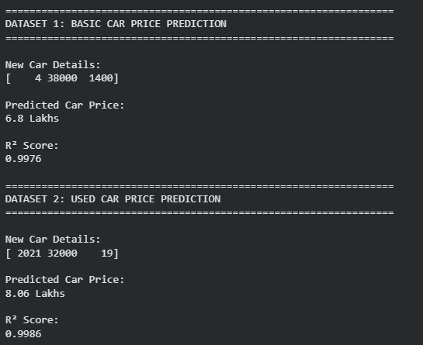
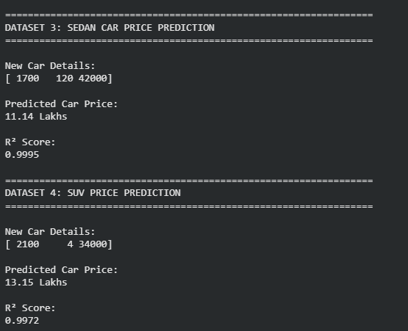
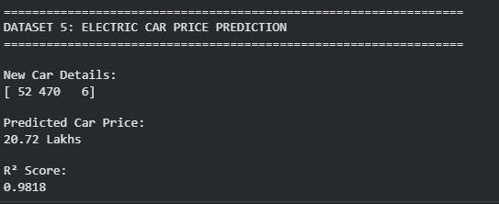

Result
The Linear Regression algorithm was successfully implemented using Scikit-learn’s LinearRegression model. The model was trained using five car-related datasets and successfully predicted the prices of the given new car samples.
14. To predict house prices using the Linear Regression algorithm.
Procedure
- Import the Linear Regression model.
- Create the dataset and target values.
- Train the model using the training data.
- Predict the house price for a new input.
- Display the predicted result.

Dataset 1: House Size, Bedrooms, and Age
House Size (sq.ft) | Bedrooms | House Age (Years) | House Price (₹ Lakhs)
800 | 2 | 15 | 35
1000 | 2 | 12 | 42
1200 | 3 | 10 | 52
1400 | 3 | 8 | 63
1600 | 4 | 6 | 75
1800 | 4 | 5 | 88
2000 | 5 | 4 | 102
2200 | 5 | 3 | 118
2400 | 6 | 2 | 135
2600 | 6 | 1 | 150

Target Variable
House Price (₹ Lakhs)

New Sample
House Size | Bedrooms | House Age
1700 | 4 | 5

Dataset 2: House Area, Distance from City, and Parking
Area (sq.ft) | Distance from City (km) | Parking Spaces | House Price (₹ Lakhs)
900 | 20 | 1 | 40
1100 | 18 | 1 | 48
1300 | 16 | 2 | 60
1500 | 14 | 2 | 74
1700 | 12 | 2 | 88
1900 | 10 | 3 | 104
2100 | 8 | 3 | 122
2300 | 6 | 4 | 142
2500 | 5 | 4 | 165
2700 | 3 | 5 | 190

Target Variable
House Price (₹ Lakhs)

New Sample
Area | Distance from City | Parking Spaces
1800 | 11 | 3

Dataset 3: House Area, Floors, and Garden Size
House Area (sq.ft) | Floors | Garden Area (sq.ft) | House Price (₹ Lakhs)
1000 | 1 | 100 | 45
1200 | 1 | 120 | 55
1400 | 2 | 150 | 68
1600 | 2 | 180 | 82
1800 | 2 | 200 | 96
2000 | 3 | 240 | 112
2200 | 3 | 280 | 130
2400 | 3 | 320 | 150
2600 | 4 | 350 | 172
2800 | 4 | 400 | 196

Target Variable
House Price (₹ Lakhs)

New Sample
House Area | Floors | Garden Area
2100 | 3 | 250

Dataset 4: Apartment Price Prediction
Apartment Size (sq.ft) | Floor Number | Building Age (Years) | House Price (₹ Lakhs)
700 | 1 | 15 | 30
850 | 2 | 12 | 38
1000 | 3 | 10 | 48
1150 | 4 | 8 | 60
1300 | 5 | 7 | 72
1450 | 6 | 5 | 86
1600 | 7 | 4 | 100
1750 | 8 | 3 | 116
1900 | 9 | 2 | 134
2050 | 10 | 1 | 154

Target Variable
House Price (₹ Lakhs)

New Sample
Apartment Size | Floor Number | Building Age
1500 | 6 | 4

Dataset 5: Independent House Price Prediction
Plot Area (sq.ft) | Built-up Area (sq.ft) | Number of Bathrooms | House Price (₹ Lakhs)
1200 | 900 | 2 | 48
1400 | 1100 | 2 | 60
1600 | 1300 | 3 | 74
1800 | 1500 | 3 | 90
2000 | 1700 | 4 | 108
2200 | 1900 | 4 | 128
2400 | 2100 | 5 | 150
2600 | 2300 | 5 | 174
2800 | 2500 | 6 | 200
3000 | 2700 | 6 | 228

Target Variable
House Price (₹ Lakhs)

New Sample
Plot Area | Built-up Area | Bathrooms
2300 | 2000 | 4

Procedure for Linear Regression (House Price Prediction)
Use the following procedure for each dataset.

Step 1: Import the Linear Regression Model
from sklearn.linear_model import LinearRegression

Step 2: Create the Dataset
Separate the data into:
- Input Features (X)
- Target Values (y)

Step 3: Train the Model
model = LinearRegression()
model.fit(X, y)

Step 4: Predict the House Price
prediction = model.predict(new_sample)

Step 5: Display the Predicted Result
print("Predicted House Price:", prediction)

Suggested CSV File Names
- house_price_dataset1.csv
- house_price_dataset2.csv
- house_price_dataset3.csv
- apartment_price_dataset.csv
- independent_house_dataset.csv
These datasets are appropriate for Machine Learning laboratory experiments on Linear Regression. They provide realistic housing data with continuous target values and can be directly used to build and evaluate house price prediction models in Python using Scikit learn.

Aim
To implement the Linear Regression algorithm using Python and predict house prices based on features such as:
- House size
- Number of bedrooms
- House age
- Distance from the city
- Parking spaces
- Number of floors
- Garden area
- Apartment floor number
- Plot area
- Built-up area
- Number of bathrooms

Procedure
- Import the LinearRegression model.
- Create the input dataset X and target values y.
- Train the Linear Regression model using the given data.
- Provide the new house details.
- Predict the house price.
- Display the predicted result.
Program:
import numpy as np

from sklearn.linear_model import LinearRegression

def house_price_prediction(
X,
y,
new_sample,
dataset_name
):

X = np.array(X)

y = np.array(y)

new_sample = np.array(
[new_sample]
)

model = LinearRegression()

model.fit(
X,
y
)

prediction = model.predict(
new_sample
)[0]

score = model.score(
X,
y
)

print(
"\n" + "=" * 65
)

print(
dataset_name
)

print(
"=" * 65
)

print(
"\nNew House Details:"
)

print(
new_sample[0]
)

print(
"\nPredicted House Price:"
)

print(
round(
prediction,
2
),
"Lakhs"
)

print(
"\nR² Score:"
)

print(
round(
score,
4
)
)

house_dataset_1_X = [
[800, 2, 15],
[1000, 2, 12],
[1200, 3, 10],
[1400, 3, 8],
[1600, 4, 6],
[1800, 4, 5],
[2000, 5, 4],
[2200, 5, 3],
[2400, 6, 2],
[2600, 6, 1]
]

house_dataset_1_y = [
35,
42,
52,
63,
75,
88,
102,
118,
135,
150
]

new_house_1 = [
1700,
4,
5
]

house_dataset_2_X = [
[900, 20, 1],
[1100, 18, 1],
[1300, 16, 2],
[1500, 14, 2],
[1700, 12, 2],
[1900, 10, 3],
[2100, 8, 3],
[2300, 6, 4],
[2500, 5, 4],
[2700, 3, 5]
]

house_dataset_2_y = [
40,
48,
60,
74,
88,
104,
122,
142,
165,
190
]

new_house_2 = [
1800,
11,
3
]

house_dataset_3_X = [
[1000, 1, 100],
[1200, 1, 120],
[1400, 2, 150],
[1600, 2, 180],
[1800, 2, 200],
[2000, 3, 240],
[2200, 3, 280],
[2400, 3, 320],
[2600, 4, 350],
[2800, 4, 400]
]

house_dataset_3_y = [
45,
55,
68,
82,
96,
112,
130,
150,
172,
196
]

new_house_3 = [
2100,
3,
250
]

apartment_X = [
[700, 1, 15],
[850, 2, 12],
[1000, 3, 10],
[1150, 4, 8],
[1300, 5, 7],
[1450, 6, 5],
[1600, 7, 4],
[1750, 8, 3],
[1900, 9, 2],
[2050, 10, 1]
]

apartment_y = [
30,
38,
48,
60,
72,
86,
100,
116,
134,
154
]

new_apartment = [
1500,
6,
4
]

independent_house_X = [
[1200, 900, 2],
[1400, 1100, 2],
[1600, 1300, 3],
[1800, 1500, 3],
[2000, 1700, 4],
[2200, 1900, 4],
[2400, 2100, 5],
[2600, 2300, 5],
[2800, 2500, 6],
[3000, 2700, 6]
]

independent_house_y = [
48,
60,
74,
90,
108,
128,
150,
174,
200,
228
]

new_independent_house = [
2300,
2000,
4
]

house_price_prediction(
house_dataset_1_X,
house_dataset_1_y,
new_house_1,
"DATASET 1: HOUSE SIZE, BEDROOMS AND AGE"
)

house_price_prediction(
house_dataset_2_X,
house_dataset_2_y,
new_house_2,
"DATASET 2: AREA, CITY DISTANCE AND PARKING"
)

house_price_prediction(
house_dataset_3_X,
house_dataset_3_y,
new_house_3,
"DATASET 3: HOUSE AREA, FLOORS AND GARDEN"
)

house_price_prediction(
apartment_X,
apartment_y,
new_apartment,
"DATASET 4: APARTMENT PRICE PREDICTION"
)

house_price_prediction(
independent_house_X,
independent_house_y,
new_independent_house,
"DATASET 5: INDEPENDENT HOUSE PRICE"
)
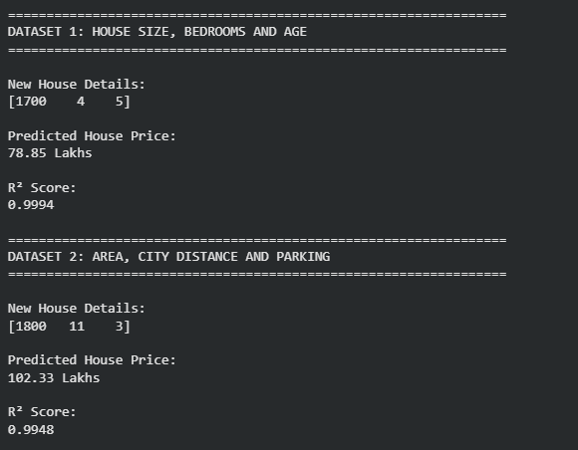
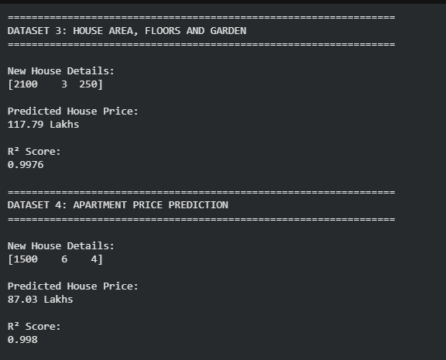
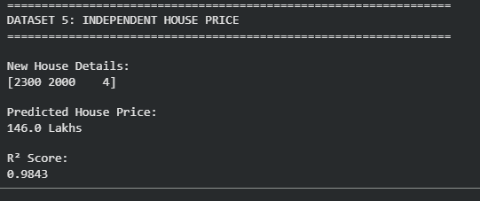

Result
The Linear Regression algorithm was successfully implemented using Scikit-learn’s LinearRegression model. The model was trained using five housing datasets and successfully predicted the prices of the given new house samples.

